“**FARMER’S SELLING GOOD’S ONLINE**”

A Report submitted under Project-Based Learning

In Partial Fulfillment of the Course Requirements for

“Web Technologies (22IT104001)”

Submitted By

|  |  |
| --- | --- |
| **A. SURENDRA** | **(22101A010352)** |

Under the Guidance of

**Ms K. Brinda**

Designation

Department of CSE(AIML)



**Department of Computer Science and Engineering**

**School of Computing**

**MOHAN BABU UNIVERSITY**

Sree Sainath Nagar, Tirupati – 517 102

**2024-2025**

**MOHAN BABU UNIVERSITY**

**Vision**

To be a globally respected institution with an innovative and entrepreneurial culture that offers transformative education to advance sustainability and societal good.

**Mission**

* Develop industry-focused professionals with a global perspective.
* Offer academic programs that provide transformative learning experience founded on the spirit of curiosity, innovation, and integrity.
* Create confluence of research, innovation, and ideation to bring about sustainable and socially relevant enterprises.
* Uphold high standards of professional ethics leading to harmonious relationship with environment and society.

**SCHOOL OF COMPUTING**

**Vision**

To lead the advancement of computer science research and education that has real-world impact and to push the frontiers of innovation in the field.

**Mission**

* Instil within our students fundamental computing knowledge, a broad set of skills, and an inquisitive attitude to create innovative solutions to serve industry and community.
* Provide an experience par excellence with our state-of-the-art research, innovation, and incubation ecosystem to realise our learners’ fullest potential.
* Impart continued education and research support to working professionals in the computing domain to enhance their expertise in the cutting-edge technologies.
* Inculcate among the computing engineers of tomorrow with a spirit to solve societal challenges.

**DEPARTMENT OF COMPUTER SCIENCE AND ENGINEERING**

**Vision**

To become a Centre of Excellence in Computer Science and its emerging areas by imparting high quality education through teaching, training and research.

**Mission**

* Imparting quality education in Computer Science and Engineering and emerging areas of IT industry by disseminating knowledge through contemporary curriculum, competent faculty and effective teaching-learning methodologies.
* Nurture research, innovation and entrepreneurial skills among faculty and students to contribute to the needs of industry and society.
* Inculcate professional attitude, ethical and social responsibilities for prospective and promising engineering profession.
* Encourage students to engage in life-long learning by creating awareness of the contemporary developments in Computer Science and Engineering and its emerging areas.

**B.Tech. Computer Science and Engineering**

**PROGRAM EDUCATIONAL OBJECTIVES**

After few years of graduation, the graduates of B.Tech. CSE will be:

1. Pursuing higher studies in core, specialized or allied areas of Computer Science, or Management.
2. Employed in reputed Computer and I.T organizations or Government to have a globally competent professional career in Computer Science and Engineering domain or be successful Entrepreneurs.
3. Able to demonstrate effective communication, engage in teamwork, exhibit leadership skills and ethical attitude, and achieve professional advancement through continuing education.

**PROGRAM OUTCOMES**

On successful completion of the Program, the graduates of B.Tech. CSE Program will be able to:

1. **Engineering Knowledge**: Apply the knowledge of mathematics, science, engineering fundamentals, and an engineering specialization to the solution of complex engineering problems.
2. **Problem Analysis**: Identify, formulate, review research literature, and analyze complex engineering problems reaching substantiated conclusions using first principles of mathematics, natural sciences, and engineering sciences.
3. **Design/Development of Solutions**: Design solutions for complex engineering problems and design system components or processes that meet the specified needs with appropriate consideration for the public health and safety, and the cultural, societal, and environmental considerations.
4. **Conduct Investigations of Complex Problems**: Use research-based knowledge and research methods including design of experiments, analysis and interpretation of data, and synthesis of the information to provide valid conclusions.
5. **Modern Tool Usage**: Create, select, and apply appropriate techniques, resources, and modern engineering and IT tools including prediction and modeling to complex engineering activities with an understanding of the limitations.
6. **The Engineer and Society**: Apply reasoning informed by the contextual knowledge to assess societal, health, safety, legal and cultural issues and the consequent responsibilities relevant to the professional engineering practice.
7. **Environment and Sustainability**: Understand the impact of the professional engineering solutions in societal and environmental contexts, and demonstrate the knowledge of, and need for sustainable development.
8. **Ethics**: Apply ethical principles and commit to professional ethics and responsibilities and norms of the engineering practice.
9. **Individual and Team Work**: Function effectively as an individual, and as a member or leader in diverse teams, and in multidisciplinary settings.
10. **Communication**: Communicate effectively on complex engineering activities with the engineering community and with society at large, such as, being able to comprehend and write effective reports and design documentation, make effective presentations, and give and receive clear instructions.
11. **Project Management and Finance**: Demonstrate knowledge and understanding of the engineering and management principles and apply these to one’s own work, as a member and leader in a team, to manage projects and in multidisciplinary environments.
12. **Life-long Learning**: Recognize the need for, and have the preparation and ability to engage in independent and life-long learning in the broadest context of technological change.

**PROGRAM SPECIFIC OUTCOMES**

On successful completion of the Program, the graduates of B. Tech. (CSE) program will be able to:

**PSO1.** Apply knowledge of computer science engineering, Use modern tools, techniques and technologies for efficient design and development of computer-based systems for complex engineering problems.

**PSO2.** Design and deploy networked systems using standards and principles, evaluate security measures for complex networks, apply procedures and tools to solve networking issues.

**PSO3.** Develop intelligent systems by applying adaptive algorithms and methodologies for solving problems from inter-disciplinary domains.

**PSO4.** Apply suitable models, tools and techniques to perform data analytics for effective decision making.

| **Course Code** | **Course Title** | **L** | **T** | **P** | **S** | **C** |
| --- | --- | --- | --- | --- | --- | --- |
| **22IT104001** | **WEB TECHNOLOGIES** | 3 | - | 2 | 4 | 5 |

**COURSE OUTCOMES:** *After successful completion of this course, the students will be able to:*

1. Demonstrate knowledge on web page design elements, dynamic content and database connection.
2. Analyze user requirements to develop web applications.
3. Design client-server applications using web technologies.
4. Demonstrate problem solving skills to develop enterprise web applications.
5. Apply HTML, CSS, JavaScript, JQuery, Bootstrap and PHP technologies for device independent web application development.
6. Apply web technologies to develop interactive, dynamic and scalable web applications for societal needs.

**CO-PO-PSO Mapping Table:**

| **Course Outcomes** | **Program Outcomes** | | | | | | | | | | | | **Program Specific Outcomes** | | | |
| --- | --- | --- | --- | --- | --- | --- | --- | --- | --- | --- | --- | --- | --- | --- | --- | --- |
| **PO1** | **PO2** | **PO3** | **PO4** | **PO5** | **PO6** | **PO7** | **PO8** | **PO9** | **PO10** | **PO11** | **PO12** | **PSO1** | **PSO2** | **PSO3** | **PSO4** |
| **CO1** | 3 | 3 | 2 | - | - | - | - | - | - | - | - | - | 3 | 2 | 3 | - |
| **CO2** | 3 | 3 | 3 | 2 | 2 | - | - | - | - | - | - | - | 3 | 2 | 3 | - |
| **CO3** | 3 | 3 | 3 | 2 | 2 | - | - | - | - | - | - | - | 3 | 2 | 3 | - |
| **CO4** | 3 | 3 | 3 | 2 | 2 | - | - | - | - | - | - | - | 2 | 2 | 3 | - |
| **CO5** | 3 | 2 | 2 | 2 | 2 | 3 | - | - | - | - | - | - | 2 | 2 | 3 | - |
| **CO6** |  |  |  | 2 |  |  |  |  | 3 | 3 |  |  |  |  |  |  |
| **Course Correlation Mapping** | 3 | 3 | 3 | 2 | 2 |  |  |  | 3 | 3 |  |  | 3 | 2 | 3 |  |

*Correlation Levels: 3: High; 2: Medium; 1: Low*



**Department of Computer Science and Engineering**

CERTIFICATE

This is to certify that the Project Entitled

“**FARMER’S SELLING GOOD’S ONLINE** “

Submitted By

| **A. SURENDRA** | **(22101A010352)** |
| --- | --- |

is the work submitted under Project-Based Learning in Partial Fulfillment of the Course Requirements for “Web Technologies (22IT104001)” during 2024-2025.

**Supervisor: Head:**

###### Ms K. Brinda Dr. B. Narendra Kumar Rao

###### Department of CSE (AIML) Professor & Head

School of Computing Department of CSE(AIML)

Mohan Babu University School of Computing

Tirupati. Mohan Babu University

Tirupati.

**ACKNOWLEDGEMENTS**

First and foremost, I extend my sincere thanks to **Dr. M. Mohan Babu**, Chancellor, for his unwavering support and vision that fosters academic excellence within the institution.

My gratitude also goes to **Mr. Manchu Vishnu, Pro-Chancellor**, for creating an environment that promotes creativity and for his encouragement and commitment to student success.

I am deeply appreciative of **Prof. Nagaraj Ramrao**, Vice Chancellor, whose leadership has created an environment conducive to learning and innovation.

I would like to thank **Dr. K. Saradhi**, Registrar, for his support in creating an environment conducive to academic success.

My sincere thanks to **Dr. B.M. Satish**, Dean of the School of Engineering and Computing, for his valuable support and guidance in all academic matters.

I am also grateful to **Dr. B. Narendra Kumar Rao**, Head of the Department of Computer Science and Engineering(AIML), for her valuable insights and support.

Finally, I would like to express my deepest appreciation to my project supervisor, **Ms K. Brinda**, Department of Computer Science and Engineering for continuous guidance, encouragement, and expertise throughout this project.

Thank you all for your support and encouragement.

**Table of Contents**

| **Chapter No.** | **Title** | | **Page No.** |
| --- | --- | --- | --- |
|  | **Abstract** | | **1** |
| **1** | **Introduction** | | **2** |
|  | 1.1 | Problem Statement | 2 |
|  | 1.2 | Importance of the Problem | 2 |
|  | 1.3 | Objectives | 3 |
|  | 1.4 | Scope of the Project | 3 |
| **2** | **System Design** | | **5** |
|  | 2.1 | Architecture Diagram | 5 |
|  | 2.2 | Module Descriptions | 5 |
|  | 2.3 | Database Design | 8 |
| **3** | **Implementation** | | **9** |
|  | 3.1 | Tools and Technologies Used | 9 |
|  | 3.2 | Front-End Development | 9 |
|  | 3.3 | Integration | 11 |
| **4** | **Testing, Results and Discussion** | | **12** |
|  | 4.1 | Test Cases | 12 |
|  | 4.2 | Testing Methods | 14 |
|  | 4.3 | Output Screenshots | 16 |
|  | 4.4 | Analysis of Results | 21 |
| **5** | **Conclusion** | | **21** |
|  | 5.1 | Summary of Findings | 21 |
|  | 5.2 | Future Enhancements | 22 |
| **6** | **Appendix** | | **24** |
|  | 6.1 | Code Snippets | 24 |

**ABSTRACT**

Farmers Selling Goods Online is a pioneering platform dedicated to bridging the gap between local farmers and consumers seeking fresh, high-quality products. Our mission is to empower farmers by providing them with a user-friendly online marketplace where they can showcase and sell their goods directly to customers. From organic fruits and vegetables to artisanal cheeses and handmade preserves, our website offers a diverse range of products, all sourced directly from dedicated farmers.

Customers can browse an extensive selection of seasonal produce, ensuring they enjoy the freshest offerings available. By purchasing through our platform, consumers not only support local agriculture but also contribute to sustainable farming practices. Each product is accompanied by detailed descriptions and farmer profiles, fostering transparency and trust in the buying process.

Our streamlined ordering system makes it easy for customers to shop from the comfort of their homes, with convenient delivery options to meet their needs. We prioritize quality and freshness, ensuring that every purchase reflects the hard work and dedication of our farmers. Join us in promoting a more sustainable food system by shopping local and supporting the farmers who nourish our communities. Experience the taste of farm-fresh goods today at Farmers Selling Goods Online.

1. **INTRODUCTION**

**1.1 Problem Statement**

Farmers face significant challenges in reaching consumers directly, often relying on intermediaries that diminish their profit margins and limit their visibility in the marketplace. This disconnect results in a lack of access for consumers who desire fresh, locally sourced products. Additionally, consumers often struggle to find reliable sources for high-quality agricultural goods, leading to a reliance on mass-produced alternatives.

The absence of a dedicated online platform means that many small-scale farmers miss out on potential sales, while consumers remain unaware of the diverse offerings available in their local areas. This gap not only affects the livelihoods of farmers but also impacts the community’s ability to engage in sustainable eating practices. There is a pressing need for an accessible, user-friendly online marketplace that connects farmers directly with consumers, promoting local economies and enhancing food security.

**1.2 Importance of the Problem**

The disconnect between farmers and consumers has far-reaching implications for both local economies and community health. Firstly, by limiting farmers' access to direct sales channels, we hinder their potential to earn a fair income, which can stifle agricultural innovation and sustainability. Small-scale farmers often struggle to compete with large agribusinesses, resulting in a decline in local food production and a loss of biodiversity.

For consumers, the inability to source fresh, locally grown produce can lead to a reliance on processed foods, which may be less nutritious and more harmful to health. Access to fresh, seasonal foods is crucial for promoting healthy diets and reducing the prevalence of diet-related diseases. Furthermore, supporting local agriculture fosters community resilience, ensuring that local economies thrive even in times of broader economic challenges.

Additionally, purchasing directly from farmers reduces the carbon footprint associated with food transportation, contributing to environmental sustainability. By creating a direct link between farmers and consumers, we can cultivate a sense of community, encourage responsible consumption, and empower individuals to make informed choices about their food sources. Addressing this problem is essential not only for the livelihoods of farmers but also for the well-being of consumers and the health of our planet.

**1.3 Objectives**

The primary objectives of the Farmers Selling Goods online project are as follows:

1. **Direct Farmer Access**: Create a user-friendly online platform that enables farmers to directly list and sell their products to consumers, eliminating intermediaries.
2. **Support Local Economies**: Encourage consumers to purchase locally, thereby boosting the income of small-scale farmers and fostering community resilience.
3. **Promote Sustainable Practices**: Advocate for and support sustainable farming practices by connecting consumers with farmers who prioritize environmentally friendly methods.
4. **Enhance Product Diversity**: Showcase a wide variety of products, including seasonal fruits, vegetables, dairy, and artisanal goods, to meet diverse consumer preferences.
5. **Educate Consumers**: Provide information about the benefits of buying local, including health advantages and the positive impact on the environment and community.
6. **Facilitate Transparency**: Offer detailed profiles of farmers and their farming practices to build trust and transparency between producers and consumers.
7. **Streamline Ordering and Delivery**: Implement an efficient ordering system with flexible delivery options, making it easy for consumers to receive fresh products.
8. **Foster Community Engagement**: Create a platform that encourages interaction between farmers and consumers, including reviews, feedback, and educational content.
9. **Expand Market Reach**: Help farmers expand their market reach beyond traditional boundaries, increasing their customer base and sales potential.
10. **Monitor and Evaluate Impact**: Regularly assess the platform’s effectiveness in enhancing farmer income, consumer satisfaction, and community health, using feedback for continuous improvement.

**1.4 Scope of the Project**

1. **Platform Development**: Build a robust, user-friendly website that allows farmers to create profiles, list products, manage inventory, and process orders efficiently.
2. **Product Range**: Include a wide variety of agricultural products, such as fresh produce, dairy, meats, grains, and artisanal goods, to cater to diverse consumer needs.
3. **User Experience**: Focus on an intuitive interface for both farmers and consumers, ensuring easy navigation, search functionality, and streamlined checkout processes.
4. **Marketing and Outreach**: Develop marketing strategies to promote the platform to farmers and consumers, highlighting the benefits of local sourcing and supporting community agriculture.
5. **Educational Resources**: Provide resources for both farmers and consumers, including best practices for sustainable farming, cooking tips, and the nutritional benefits of local foods.
6. **Community Engagement**: Foster a sense of community through features like forums, events, and farmer spotlight articles, encouraging interaction between consumers and producers.
7. **Payment and Delivery Solutions**: Implement secure payment gateways and explore logistics partnerships to offer reliable delivery options, ensuring timely access to fresh products.
8. **Monitoring and Analytics**: Establish systems to track sales, customer feedback, and market trends, allowing for data-driven improvements to the platform and services.
9. **Scaling Opportunities**: Plan for future scalability, including the potential to expand to new regions, integrate additional product lines, or develop mobile applications.
10. **Sustainability Initiatives**: Explore collaborations with local organizations to promote sustainable practices and initiatives, enhancing the platform's social impact and visibility in the community.

**System Design**

**2.1 Architecture Diagram:** *Figure 1*: project Architectural Flow

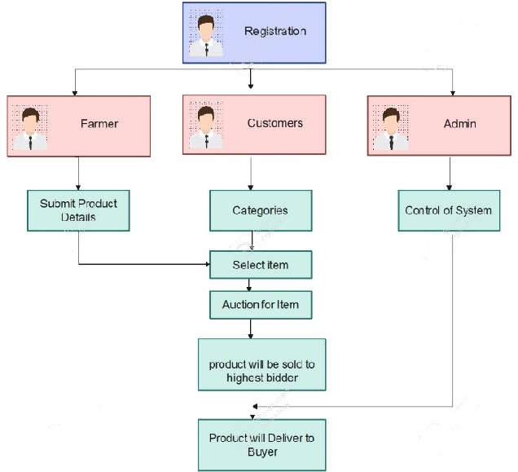

**Architecture diagram:**

1. **Registration:**
   * All users (Farmer, Customers, Admin) must go through a registration process to access the system.
2. **Farmer:**
   * Farmers can submit product details to list their items for auction.
3. **Customers:**
   * Customers can view categories of available items.
   * They can select items from the list to participate in the auction.
   * The auction process begins for the selected items, where customers place bids**.**
4. **Auction Process:**
   * Products are auctioned, and the highest bidder wins the item.
5. **Product Sale:**
   * The product is sold to the highest bidder.
6. **Delivery:**
   * The product is delivered to the buyer (the highest bidder).
7. **Admin:**
   * Admin has control over the system and manages overall functionality, likely overseeing user activity and ensuring system stability.

This architecture allows for a structured auction process involving registration, product listing, bidding, and final delivery of goods to buyers.

**2.2 Module Description:**

**1. Registration Module:**

* **Purpose:** Allows users (Farmers, Customers, and Admin) to create accounts and access the system.
* **Functionality:**
  + Collects basic user information.
  + Verifies and stores user credentials.
  + Assigns roles based on the type of user (Farmer, Customer, or Admin).
  + Manages user login and authentication.

**2. Farmer Module:**

* **Purpose:** Enables farmers to submit and manage their products for auction.
* **Functionality:**
  + Allows farmers to add product details (name, description, category, quantity, etc.).
  + Provides an interface for managing listed products (e.g., editing or removing product listings).
  + Allows farmers to view the auction status of their products and track bids.
  + Enables communication with the admin if support or verification is needed.

**3. Customer Module:**

* **Purpose**: Allows customers to browse products, participate in auctions, and bid on items.
* **Functionality:**
  + Displays product categories and details for easy browsing.
  + Allows customers to select items they are interested in bidding on.
  + Facilitates the bidding process, including setting bid limits and notifying customers of bid changes.
  + Updates the highest bid in real-time and shows auction progress.
  + Provides a summary of items the customer has bid on, with the current status of each auction.

**4. Auction Management Module**

* **Purpose:** Manages the auction process, ensuring fair bidding and accurate selection of the highest bidder.
* **Functionality:**
  + Starts and closes auctions at designated times.
  + Tracks all bids placed on each product and updates the highest bid.
  + Determines and displays the winner (highest bidder) once the auction ends.
  + Sends notifications to the winning customer and the farmer upon auction completion.
  + Maintains records of completed auctions for reference and reporting.

**5. Product Delivery Module:**

* **Purpose:** Handles the post-auction process, ensuring that sold products are delivered to the winning customers.
* **Functionality:**
  + Notifies farmers to prepare products for shipment after an auction ends.
  + Allows customers to track delivery status.
  + Enables communication between farmers, customers, and the system admin to resolve any delivery issues.
  + Records successful deliveries and provides feedback options for both parties.

**6. Admin Module:**

* **Purpose:** Provides control and oversight of the entire system to ensure smooth operation and resolve issues.
* **Functionality:**
  + Manages user roles and permissions.
  + Monitors all product listings and auctions to prevent fraud or misconduct.
  + Provides support to farmers and customers, helping resolve registration, bidding, or delivery issues.
  + Manages system settings, including auction rules, timing, and notifications.
  + Generates reports and analytics on system usage, auction outcomes, and delivery statuses.

This module breakdown defines how each part of the system functions to facilitate the entire online auction process, from user registration and product listing to auction and delivery, under the oversight of an admin.

**2.3 Database Design**

1. **Users**: Stores information about farmers and customers.
   * Key fields: user_id, user_type (farmer/customer), name, email, address.
2. **Products**: Contains details of goods listed by farmers.
   * Key fields: product_id, farmer_id (from Users), product_name, category, price, stock, status.
3. **Orders**: Manages customer orders.
   * Key fields: order_id, customer_id (from Users), order_date, status, total_amount.
4. **Order Items**: Lists specific items in each order.
   * Key fields: order_item_id, order_id (from Orders), product_id (from Products), quantity, price.
5. **Payments**: Tracks payment details.
   * Key fields: payment_id, order_id (from Orders), payment_date, amount, payment_method, status.
6. **Reviews**: Allows customers to review products.
   * Key fields: review_id, product_id (from Products), customer_id (from Users), rating, comment.
7. **Inventory Log**: Logs stock changes.
   * Key fields: log_id, product_id (from Products), change, change_type, change_date.
8. **Categories**: Defines product categories.
   * Key fields: category_id, category_name, description.

**Relationships**

* **Users** link to **Products** (farmer’s products).
* **Orders** link to **Users** (customer orders) and **Payments**.
* **Order Items** link **Orders** to specific **Products**.
* **Reviews** link **Users** to **Products** (customer feedback).

**Implementation**

**3.1 Tools & Technologies used**

**Frontend Technologies**

* **HTML/CSS**: For website structure and styling.
* **JavaScript**: Adds interactivity and dynamic features.
* **React / Vue.js / Angular**: Popular JavaScript frameworks for building responsive, interactive user interfaces.

**3.2 Front-End Development**

**1. User Interface (UI) Design**

* **Homepage**: Design a clean and welcoming homepage that showcases featured products, categories (like fruits, vegetables, dairy), and seasonal promotions.
* **Product Listing Page**: Display product images, names, prices, and ratings in an organized grid or list view. Filtering and sorting options (e.g., by price, category) help users find what they’re looking for easily.
* **Product Detail Page**: Each product should have a dedicated page with high-quality images, a detailed description, price, stock availability, and reviews. Include an "Add to Cart" button for quick purchasing.
* **Farmer Profiles**: Each farmer could have a profile page showing their farm information, types of products they sell, and reviews, giving customers more insight and trust.
* **Cart and Checkout**: Build a seamless cart and checkout experience, where users can review items, modify quantities, and proceed to a secure checkout.

**2. Responsive Design**

* **Mobile-Friendly Layout**: Design for mobile-first, as many customers and farmers may use mobile devices. Ensure all pages adapt well to various screen sizes, using flexible grids, scalable text, and touch-friendly buttons.
* **CSS Frameworks**: Use frameworks like **Bootstrap** or **Tailwind CSS** to create a consistent, responsive layout across devices and screen sizes, speeding up the development process.

**3. Interactivity and User Experience (UX)**

* **Smooth Navigation**: Use navigation bars, dropdowns, and clear CTAs (Call-to-Action buttons) to allow users to browse easily.
* **Loading States and Animations**: Provide visual feedback during loading, especially for product images, filters, and buttons. Simple animations (using **4. State Management**

**5. API Integration**

* **Data Fetching**: Use **Axios** or native fetch for HTTP requests to interact with backend APIs. This can include fetching product lists, submitting orders, and processing payments.
* **Error Handling**: Provide users with clear, friendly messages if there’s an error (e.g., network issues, out-of-stock items).

**6. Authentication and Security**

* **User Authentication**: Enable login/signup for farmers and customers, using JWT tokens for session management.
* **Form Validation**: Ensure form validation on the frontend (e.g., email format, required fields) for a smooth checkout and registration experience.
* **Secure Payments**: For payment pages, integrate with a secure payment gateway, such as Stripe or PayPal, to ensure that sensitive information is handled safely.

**7. Testing**

* **Component Testing**: Use testing tools like **Jest** or **React Testing Library** to test individual UI components.
* **End-to-End Testing**: For user flows (e.g., browsing, adding to cart, and checkout), **Cypress** or **Puppeteer** helps simulate user interactions and catch issues early.

**8. Performance Optimization**

* **Image Optimization**: Use compressed images or lazy loading for product images to reduce load times.
* **Code Splitting**: Load only the JavaScript needed for a particular page, reducing initial load time.
* **Content Delivery Network (CDN)**: Utilize a CDN (e.g., Cloudflare) to deliver static assets quickly across various locations.

**9. Accessibility**

* **Keyboard Navigation and ARIA Labels**: Ensure that buttons, links, and forms are accessible via keyboard and use ARIA labels where necessary for screen readers.
* **Contrast and Readability**: Ensure adequate contrast for readability, particularly for product information and prices.

**3.3 Integration**

Integration for an online marketplace where farmers sell goods involves connecting various systems and services to ensure a seamless and efficient user experience. One of the primary integrations is with payment gateways, such as Stripe or PayPal, which allow secure processing of customer transactions. This integration not only facilitates the acceptance of multiple payment methods, including credit and debit cards as well as digital wallets, but also ensures the security of sensitive customer information through encryption and compliance with financial regulations.

User authentication is another crucial aspect, enabling customers to log in using their social media accounts for convenience or through a secure system using JSON Web Tokens (JWT) for session management. This keeps user data protected while providing a smooth login experience. Additionally, the backend of the website should be integrated with RESTful or GraphQL APIs to manage product listings, orders, and user accounts efficiently, ensuring real-time data updates between the frontend and backend systems.

External APIs can also enhance functionality; for example, integrating with shipping service APIs allows automatic calculation of shipping costs and tracking of orders, improving the logistics process for farmers. Furthermore, email services like SendGrid or Mailgun can be integrated to manage transactional emails, such as order confirmations and shipping notifications, as well as marketing communications.

To optimize website performance, employing a Content Delivery Network (CDN) is beneficial. CDNs, like Cloudflare, cache static assets across a global network, ensuring faster load times for users regardless of their location. Social media integrations allow for easy sharing of products and farm profiles, which can increase visibility and engagement, driving more traffic to the site.

In terms of customer relationship management, integrating tools such as HubSpot or Salesforce can help manage customer interactions and improve marketing efforts by analyzing customer data and behavior. Lastly, incorporating analytics tools like Google Analytics provides valuable insights into user behavior and sales trends, enabling both farmers and administrators to make informed decisions based on real-time data.

Overall, these integrations create a cohesive and efficient online marketplace that enhances user experience, improves operational efficiency, and drives business growth for farmers selling their goods online.

**Testing, Results & Discussion**

**4.1 Testcases**

**1. User Registration and Authentication**

* **Registration Test Cases**: Verify that users can successfully register with valid credentials, check for error messages with invalid input (e.g., invalid email format, weak password), and ensure unique email addresses.
* **Login Test Cases**: Validate successful login with correct credentials, test unsuccessful login attempts with incorrect credentials, and verify password recovery functionality.
* **Session Management**: Test session expiration after a period of inactivity and ensure users are logged out after clicking the logout button.

**2. Product Listings**

* **Product Display**: Check that all products are displayed correctly on the product listing page, including images, names, prices, and stock status.
* **Filtering and Sorting**: Validate that filtering options (e.g., by category, price range) work correctly and that sorting options (e.g., by price or popularity) sort the products as expected.
* **Search Functionality**: Test the search bar for various inputs, ensuring it returns relevant products and handles cases with no results gracefully.

**3. Product Detail Page**

* **Information Accuracy**: Verify that the product detail page displays all relevant information accurately, including descriptions, pricing, images, and reviews.
* **Add to Cart Functionality**: Test the "Add to Cart" button to ensure items can be added and that the cart updates correctly.

**4. Shopping Cart and Checkout**

* **Cart Management**: Validate that users can add, remove, and update quantities of items in their cart. Ensure that the cart persists items when users navigate away from the page or refresh.
* **Checkout Process**: Test the entire checkout flow, including entering shipping information, selecting payment methods, and placing an order. Verify that users receive confirmation upon successful order placement.
* **Payment Processing**: Validate integration with payment gateways to ensure successful transactions, handling of declined payments, and error messages for invalid payment details.

**5. Order Management**

* **Order History**: Test that users can view their order history, including details of past orders, status updates, and tracking information.
* **Order Cancellation and Returns**: Validate that users can cancel orders within allowed timeframes and request returns or exchanges.

**6. Reviews and Ratings**

* **Review Submission**: Ensure users can submit reviews for products and that the reviews display correctly on the product detail page. Test for validation of review inputs (e.g., rating within allowed range, comment length).
* **Moderation Features**: If applicable, test that submitted reviews can be moderated or flagged for inappropriate content.

**7. Admin Functionality**

* **Product Management**: Test that administrators can add, edit, and delete product listings, including updating stock levels and pricing.
* **User Management**: Validate that admins can manage user accounts, including viewing user details, suspending accounts, and managing roles.

**8. Performance Testing**

* **Load Testing**: Simulate multiple users accessing the website simultaneously to ensure it can handle high traffic without performance degradation.
* **Speed Testing**: Measure page load times and optimize any slow-loading components to enhance user experience.

**9. Responsive Design Testing**

* **Cross-Browser Compatibility**: Test the website across different browsers (Chrome, Firefox, Safari, etc.) to ensure consistent functionality and appearance.
* **Mobile Responsiveness**: Verify that the website functions properly on various devices and screen sizes, checking that layouts adjust correctly.

**10. Security Testing**

* **Input Validation**: Test for vulnerabilities such as SQL injection, cross-site scripting (XSS), and cross-site request forgery (CSRF).
* **Data Encryption**: Verify that sensitive user information, especially payment details, is encrypted during transmission.

**11. Usability Testing**

* **User Interface**: Gather feedback from real users to assess the intuitiveness and ease of use of the website. Test navigation, readability, and overall user satisfaction.

**4.2 Testing Methods**

**1. Unit Testing**

Unit testing involves testing individual components or functions of the application in isolation. This method focuses on validating the logic of specific pieces of code, ensuring that each unit performs as intended. For instance, in a shopping cart application, unit tests might verify that adding or removing items updates the cart correctly. This method is typically automated and helps catch bugs early in the development process.

**2. Integration Testing**

Integration testing evaluates the interactions between different components or systems within the application. This method ensures that combined parts of the application work together as expected. For example, testing the interaction between the payment gateway and the checkout process is crucial to ensure that payments are processed accurately. Integration tests help identify issues that may arise when different modules interact.

**3. Functional Testing**

Functional testing assesses the application against specified requirements to ensure it behaves as intended. This includes testing user interfaces, APIs, databases, and security features. For the online marketplace, functional tests might cover scenarios such as user registration, product search, and order placement. This method can be manual or automated and focuses on verifying that the system delivers the required functionality.

**4. Usability Testing**

Usability testing evaluates the user experience of the website by observing real users as they interact with it. This method aims to identify any obstacles or confusion that users may encounter. By gathering feedback on navigation, layout, and overall satisfaction, usability testing helps enhance the user interface and improve the overall experience for customers and farmers.

**5. Performance Testing**

Performance testing measures how the application behaves under varying loads, assessing its speed, scalability, and stability. This method includes load testing (to determine how many users the system can handle simultaneously), stress testing (to identify the system's breaking point), and endurance testing (to evaluate performance over an extended period). Ensuring the website can handle peak traffic is crucial for maintaining a smooth user experience.

**6. Security Testing**

Security testing aims to identify vulnerabilities and weaknesses in the application that could be exploited by malicious users. This includes testing for issues like SQL injection, cross-site scripting (XSS), and ensuring proper data encryption. Security testing is critical for protecting sensitive user data, especially in an online marketplace where financial transactions occur.

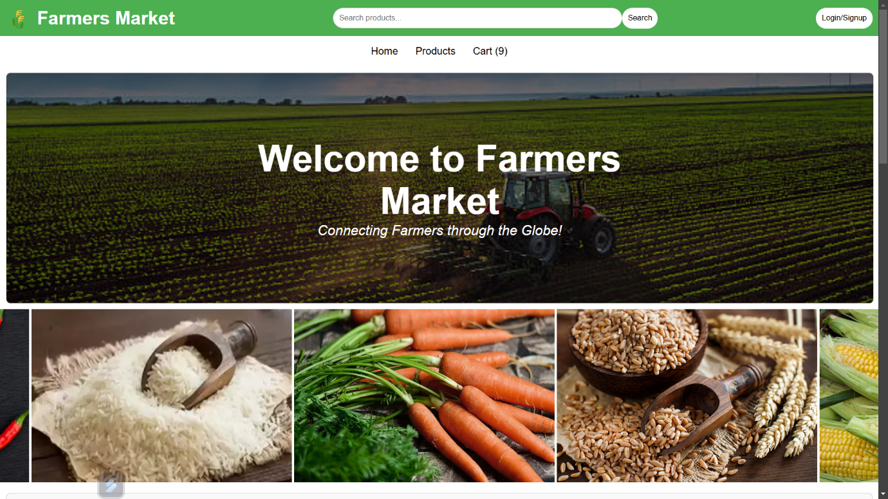**4.3 Output Screenshots**

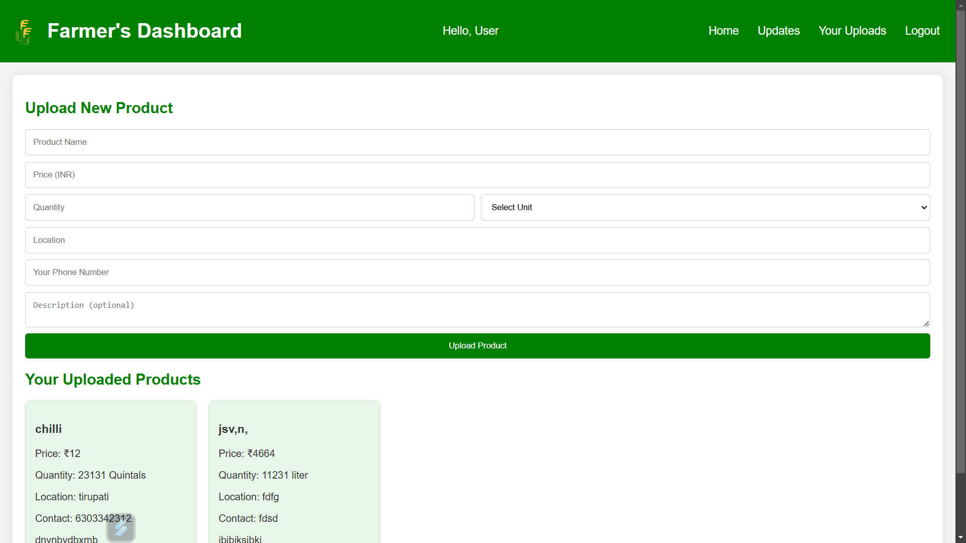

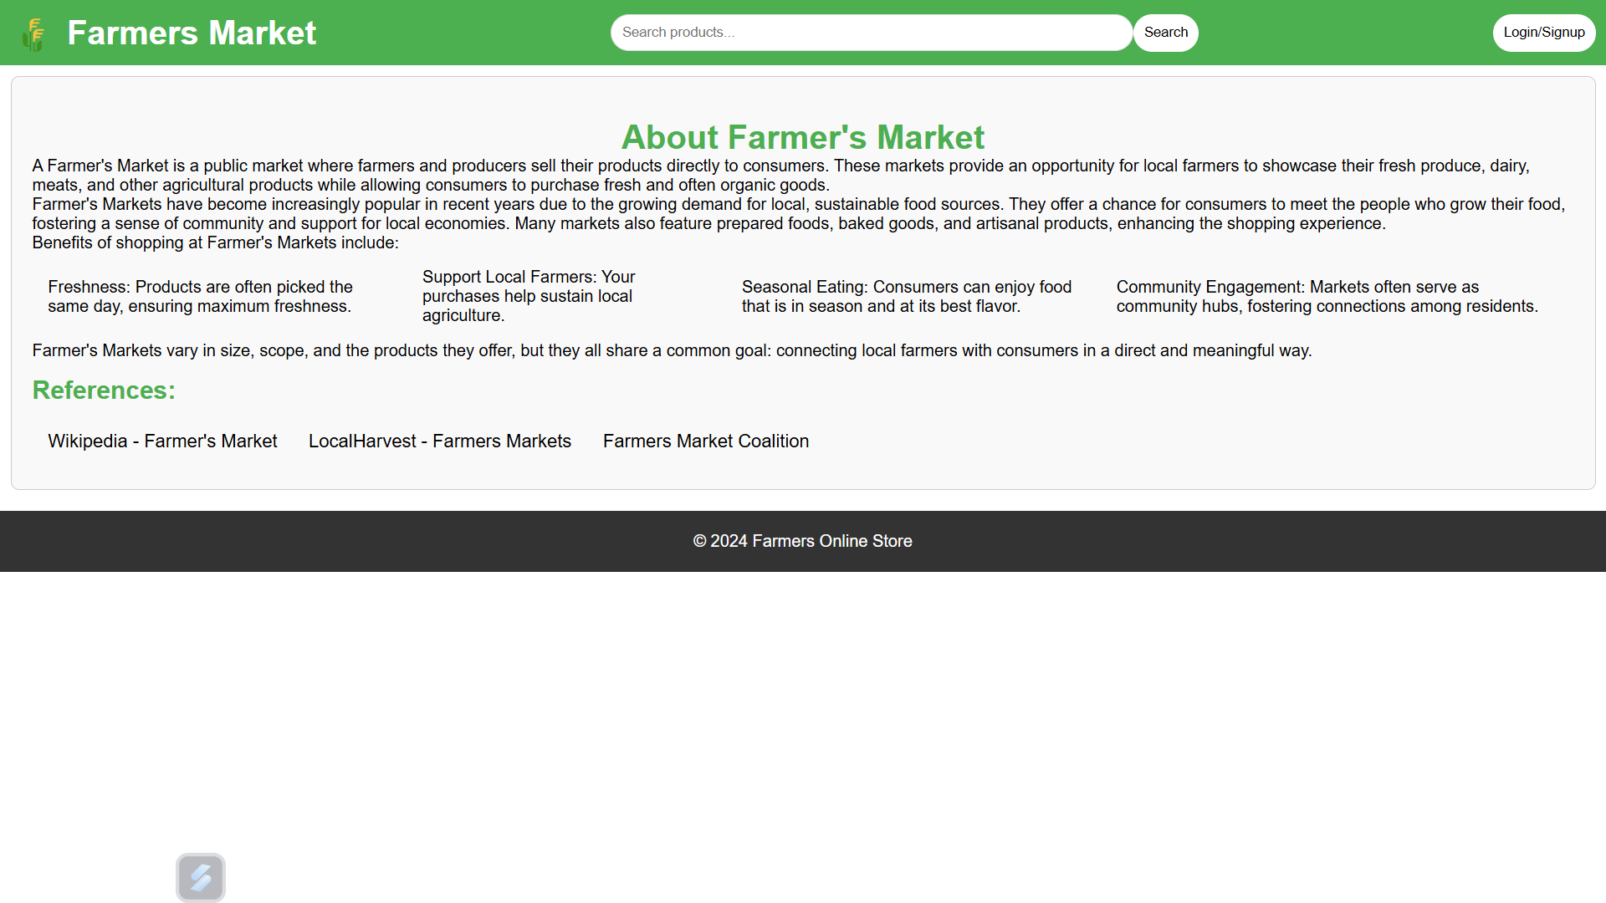

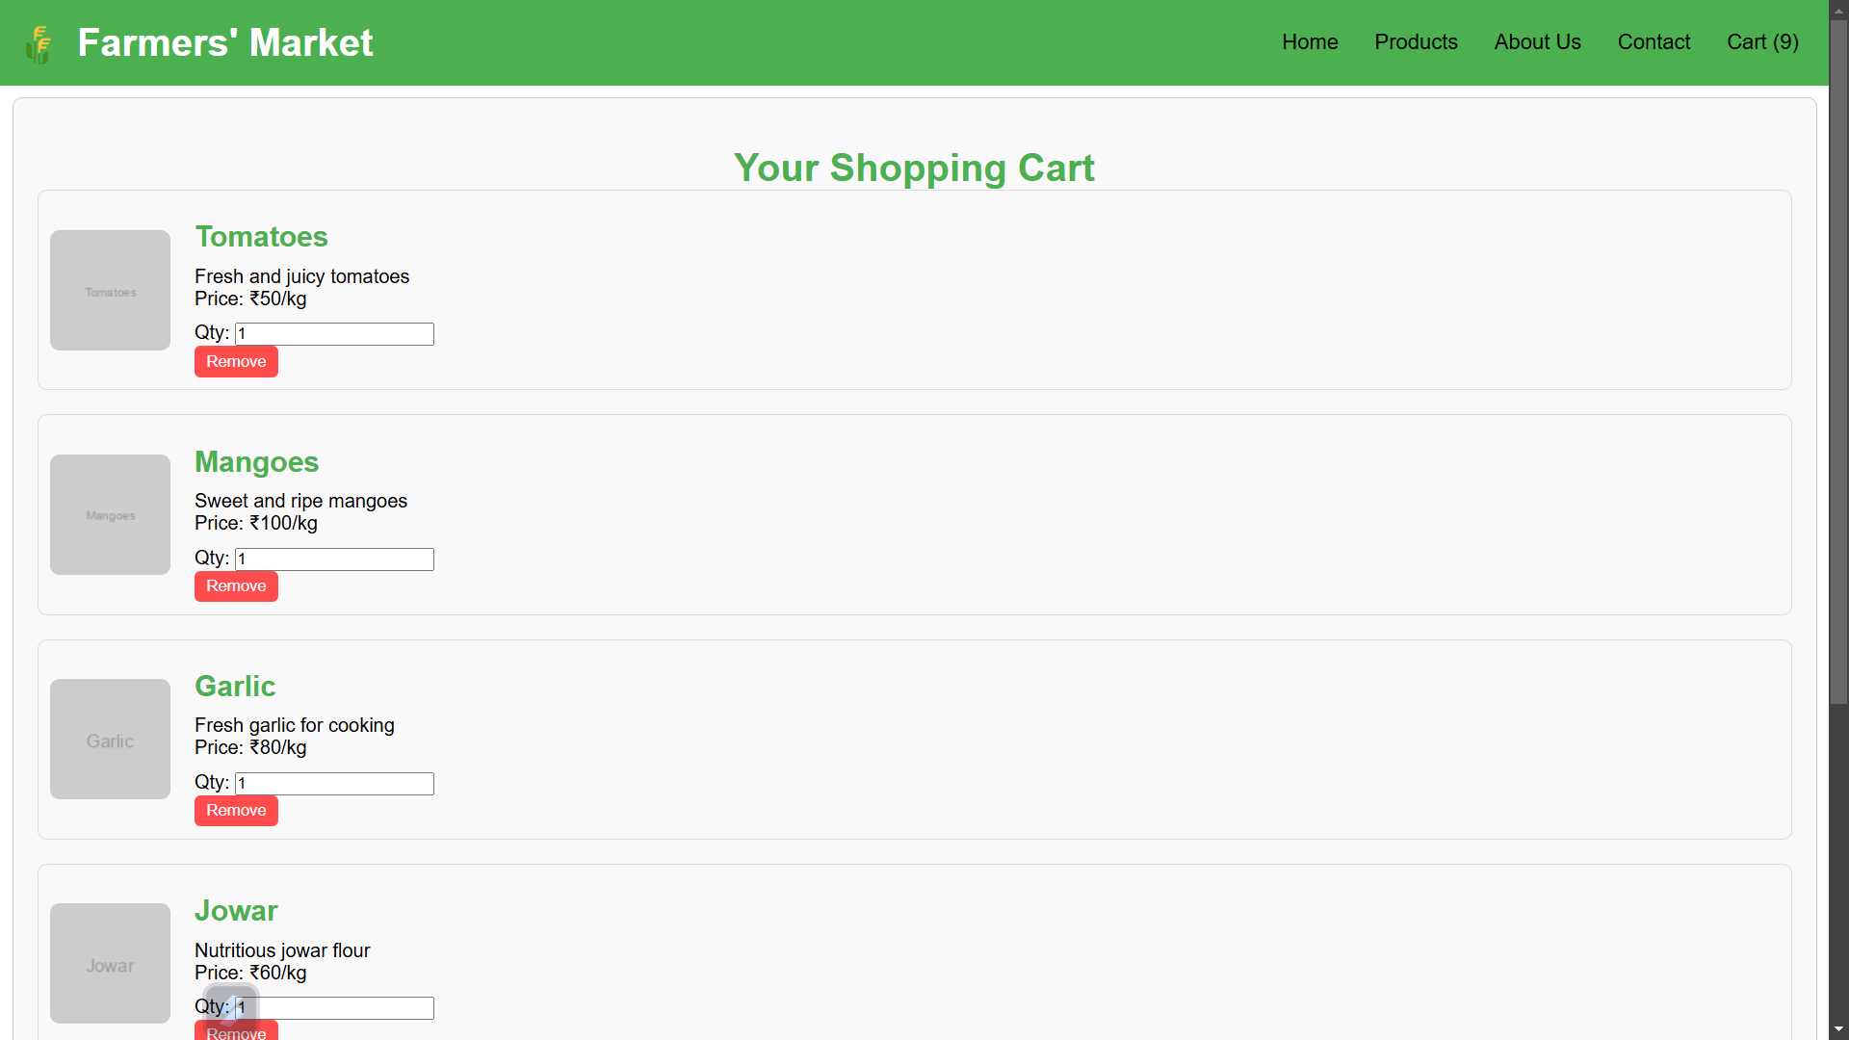

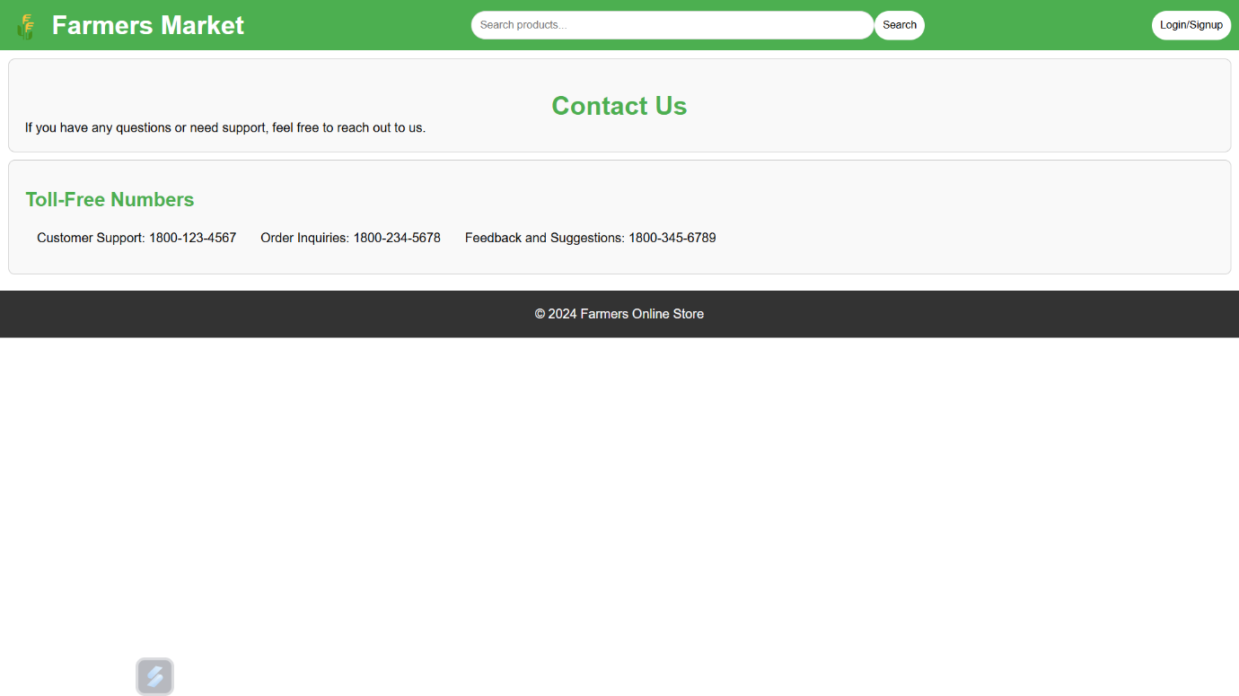

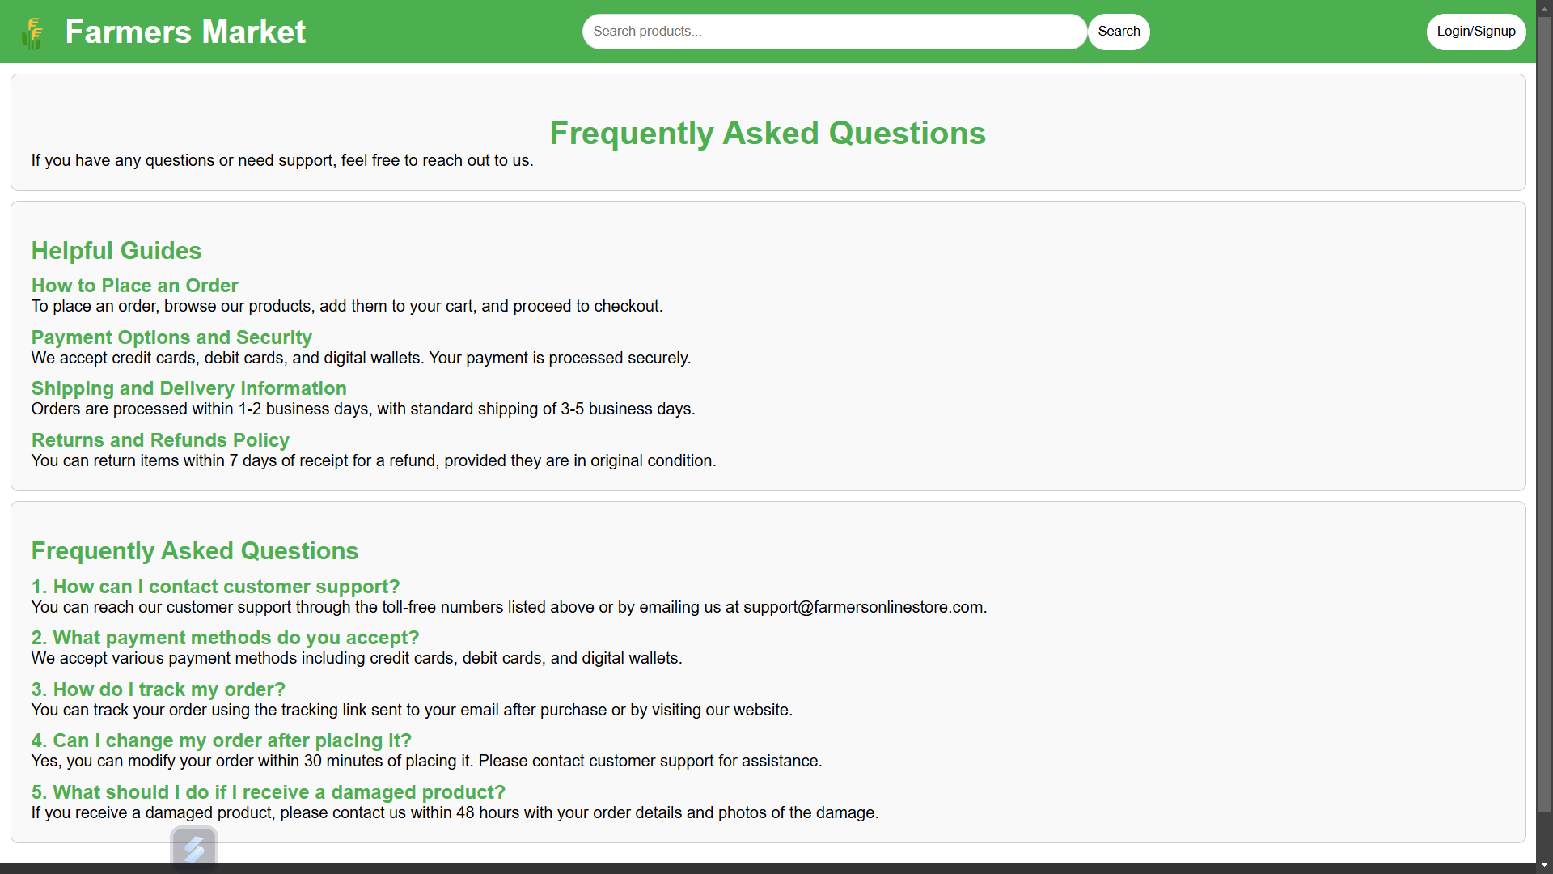

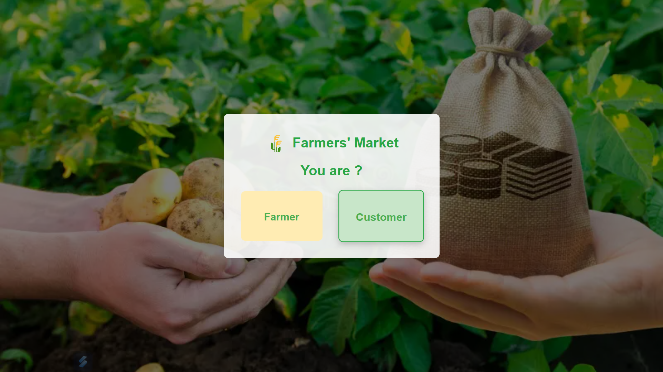

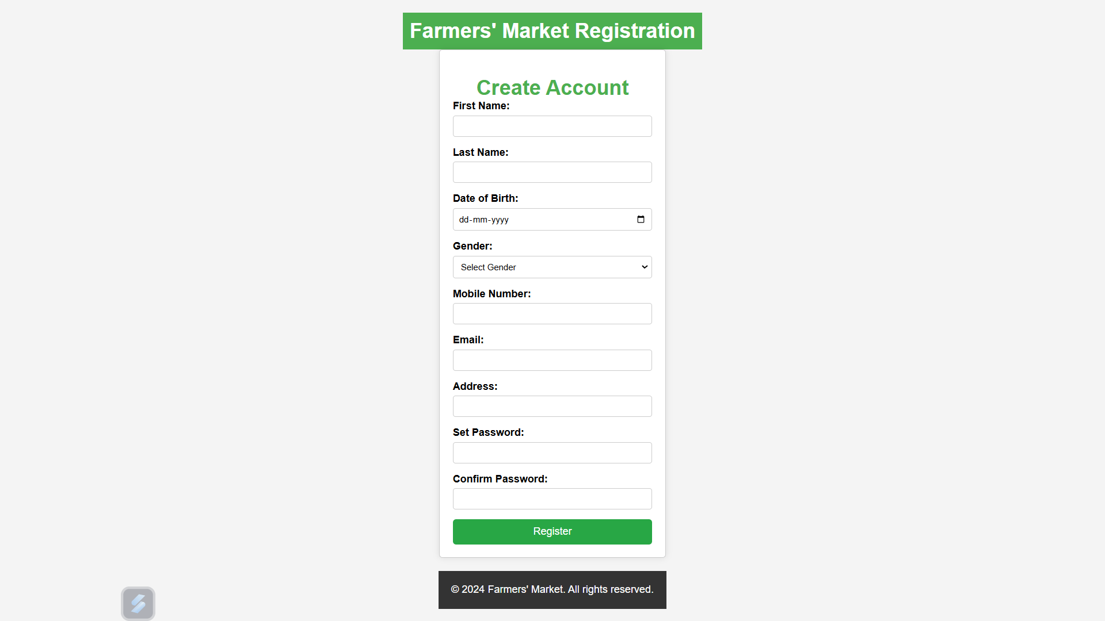

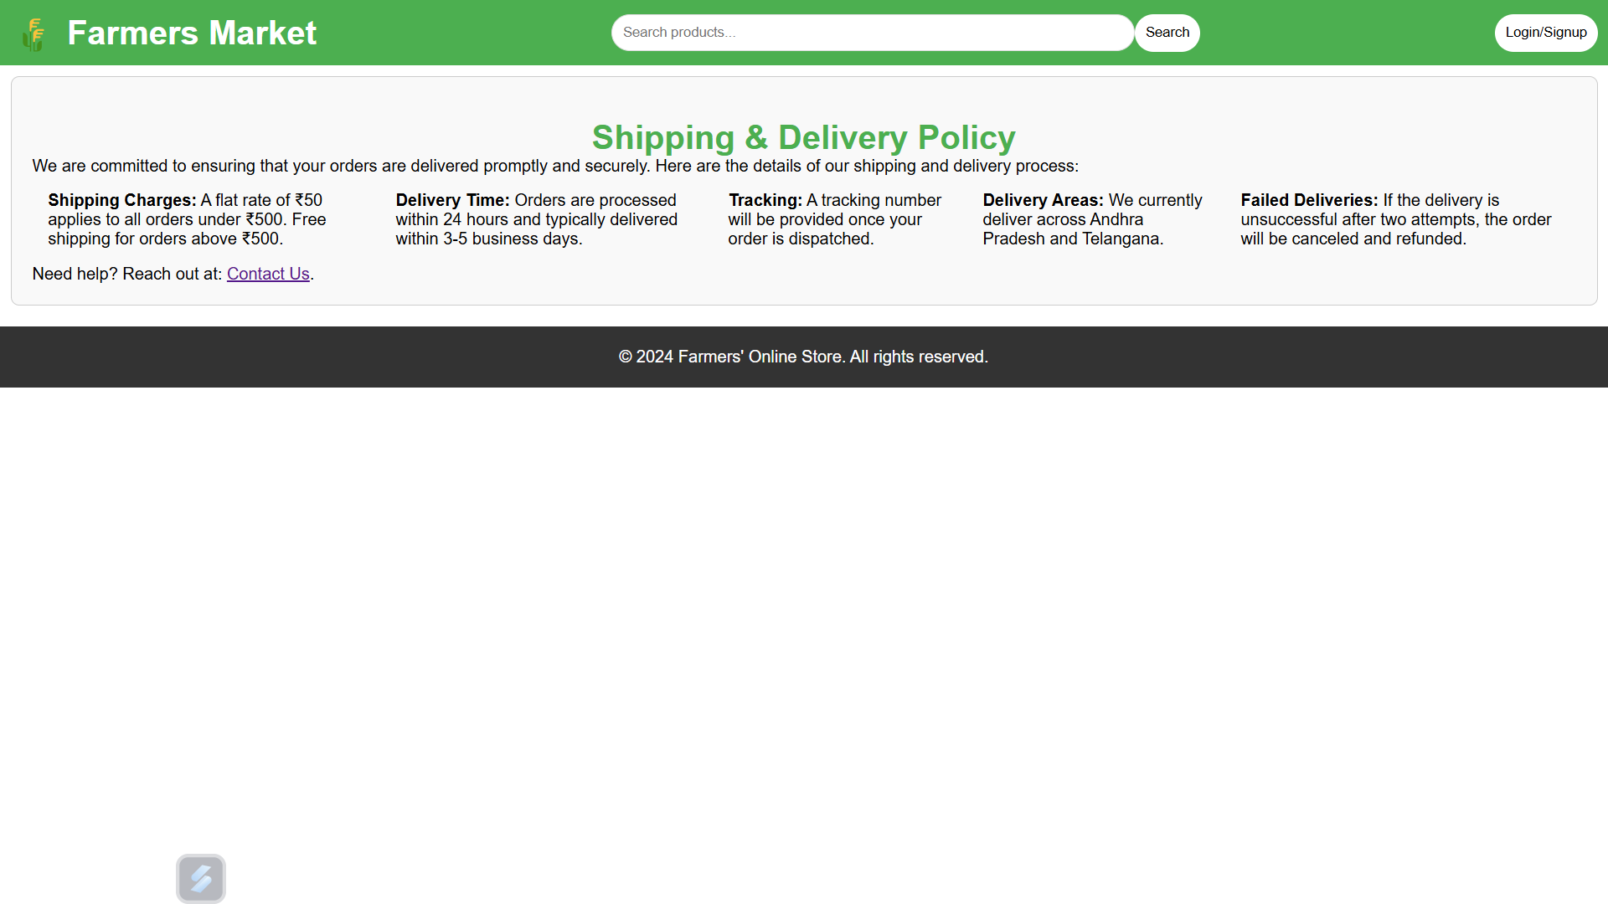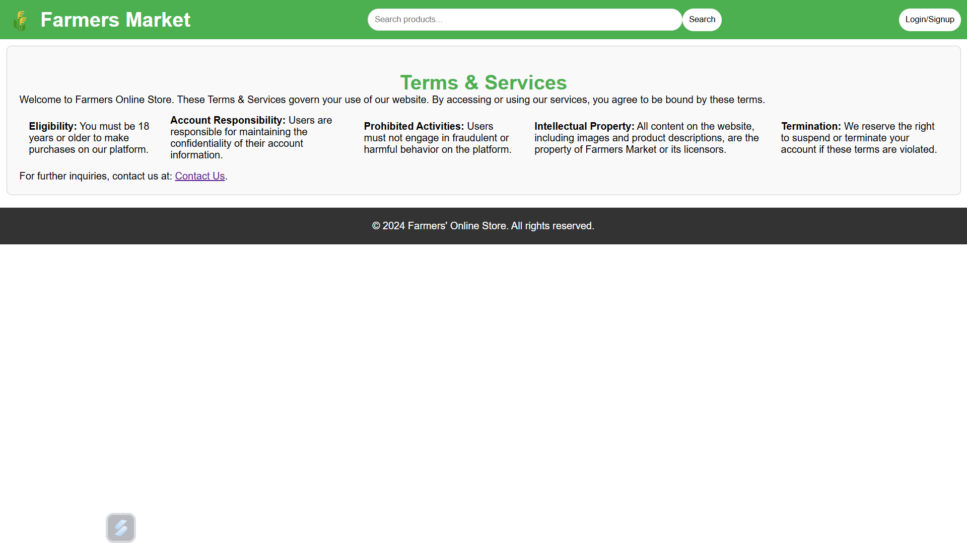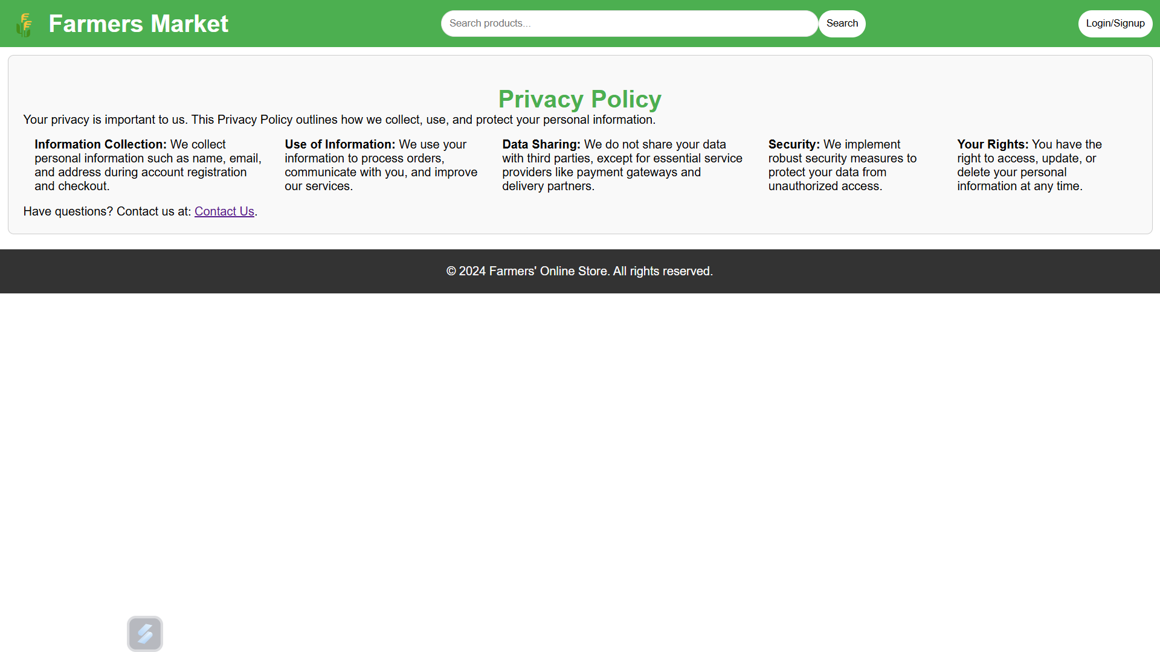

**4.4 Analysis of results**

Analyzing the results of an online marketplace for farmers involves evaluating key performance metrics and user feedback to assess the website's effectiveness. Key metrics to focus on include user engagement, conversion rates, and sales performance.

For user engagement, tracking traffic levels and bounce rates can provide insights into how well the site captures visitors' interest. A high bounce rate may indicate that users are not finding what they expect, prompting a review of content and navigation.

Conversion rates, particularly the percentage of visitors who complete a purchase and the cart abandonment rate, are critical indicators of how smoothly the purchasing process is. Identifying friction points in the checkout process can lead to enhancements that improve sales.

Sales performance metrics, such as total sales revenue and average order value (AOV), help gauge the financial health of the marketplace. Low AOV may suggest opportunities for upselling or product bundling.

Customer feedback through surveys and reviews can provide qualitative insights into user satisfaction and highlight areas for improvement. A strong Net Promoter Score (NPS) indicates customer loyalty, while negative feedback should be addressed to enhance the user experience.

Overall, regularly analyzing these results allows for informed decision-making, helping to refine strategies for better user engagement, increased sales, and improved operational efficiency in the marketplace.

**Conclusion**

**5.1 Summary of Findings**

The analysis of the online marketplace for farmers selling goods reveals several key insights that can inform future strategies and enhancements. User engagement metrics indicate a growing interest in the platform, though a high bounce rate suggests that improvements in navigation and content relevance are needed to retain visitors effectively.

Conversion rates highlight the importance of streamlining the purchasing process, as the current cart abandonment rate indicates potential friction points in the checkout flow. Enhancing user experience during checkout can significantly boost sales and overall customer satisfaction.

Sales performance metrics demonstrate a healthy revenue stream, but the average order value (AOV) indicates potential for growth through upselling and cross-selling strategies. By encouraging customers to purchase additional items or bundles, the marketplace can increase revenue per transaction.

Customer feedback, gathered through reviews and surveys, provides valuable insights into user satisfaction. Positive feedback reflects strong product quality and service, while areas of concern highlighted in negative reviews should be addressed to improve overall customer experience. A solid Net Promoter Score (NPS) suggests that loyal customers are likely to recommend the platform, further driving growth.

In conclusion, while the online marketplace shows promising results in user engagement and sales, there are clear opportunities for improvement. By focusing on enhancing the user experience, optimizing the purchasing process, and leveraging customer feedback, the marketplace can position itself for continued growth and success in the competitive online retail space. Regularly reviewing these findings will enable stakeholders to make informed decisions and adapt strategies to meet evolving customer needs.

**5.2 Future Enhancements**

**1. Improved User Experience**

* **Enhanced Navigation**: Streamlining the website’s navigation with clearer categories, filters, and search functionalities can help users find products more easily.
* **Personalization**: Implementing personalized recommendations based on user behavior and purchase history can improve engagement and increase sales.

**2. Mobile Optimization**

* **Mobile App Development**: Creating a mobile app could provide a more convenient shopping experience for users and increase accessibility.
* **Responsive Design Improvements**: Continuously optimizing the mobile version of the website to ensure fast load times and easy navigation on all devices.

**3. Advanced Payment Options**

* **Additional Payment Methods**: Integrating more payment options, such as digital wallets (e.g., Apple Pay, Google Pay) and buy-now-pay-later services, can cater to a broader audience.
* **Cryptocurrency Payments**: Considering the integration of cryptocurrency payment options for tech-savvy customers.

**4. Enhanced Product Information**

* **Rich Media Content**: Incorporating videos, detailed product descriptions, and user-generated content (like photos) can enhance product listings and provide better context for buyers.
* **Nutritional Information and Sourcing Details**: Providing more information about the products, including their nutritional value and sourcing stories, can help build trust and encourage purchases.

**5. Community Features**

* **User Forums and Q&A Sections**: Implementing community features where customers can ask questions and share experiences can enhance user engagement and build a sense of community.
* **Farmers’ Profiles**: Creating detailed profiles for farmers to share their stories, farming practices, and product details can help foster connections with consumers.

**6. Loyalty and Rewards Programs**

* **Customer Loyalty Program**: Implementing a rewards program that offers discounts, points, or exclusive deals for repeat customers can enhance retention and increase customer lifetime value.
* **Referral Incentives**: Introducing a referral program that rewards customers for bringing new users to the platform can expand the customer base.

**7. Advanced Analytics and Reporting**

* **Enhanced Analytics Tools**: Integrating advanced analytics solutions can help farmers and administrators gain deeper insights into sales trends, customer behavior, and inventory management.
* **Predictive Analytics**: Utilizing AI-driven predictive analytics can forecast demand and help in better inventory planning.

**8. Sustainability Initiatives**

* **Carbon Footprint Tracking**: Implementing features that allow customers to see the carbon footprint of their purchases and providing options for carbon offsetting can appeal to environmentally conscious consumers.
* **Eco-Friendly Product Categories**: Highlighting sustainable products or practices can attract a niche market interested in organic and eco-friendly options.

**9. Enhanced Security Features**

* **Multi-Factor Authentication (MFA)**: Implementing MFA for user accounts can enhance security and protect sensitive information.
* **Regular Security Audits**: Conducting regular security assessments to identify vulnerabilities and ensure compliance with data protection regulations.

**10. Multilingual Support**

* **Language Options**: Offering the website in multiple languages can make it accessible to a wider audience and cater to non-English speaking customers.

**Appendix**

**6.1 Code Snippets**

**1. index.html**

<!DOCTYPE html>

<html lang="en">

<head>

<meta charset="UTF-8">

<meta name="viewport" content="width=device-width, initial-scale=1.0">

<link rel="stylesheet" href="styles.css">

<script src="script.js" defer></script>

<title>Farmers' Online Store</title>

</head>

<body>

<header>

<div class="logo">

<span class="logo-icon">🌾</span>

<h1>Farmers Market</h1>

</div>

<div class="search-container">

<input type="text" placeholder="Search products..." />

<button type="button">Search</button>

</div>

<div class="signup">

<a href="login.html"><button>Login/Signup</button></a>

</div>

</header>

<header class="header2">

<ul>

<li><a href="#">Home</a></li>

<li><a href="#">Products</a></li>

<li><a href="cart.html">Cart (<span id="cart-count">0</span>)</a></li>

</ul>

</header>

<section id="hero">

<div class="hero-content">

<h1>Welcome to Farmers Market</h1>

<p><i>Connecting Farmers through the Globe!</i></p>

</div>

</section>

<marquee behavior="alternate" scrollamount="10"><img src="https://media.assettype.com/thebridgechronicle%2F2024-10-24%2F4wbqcbbn%2FChilli-Farming.jpeg?w=480&dpr=2&auto=format%2Ccompress&fit=max&q=85" height="300" width="450">

<img src="https://static.toiimg.com/thumb/msid-111157437,width-400,height-225,resizemode-72/111157437.jpg" height="300" width="450">

<img src="https://glasrestaurant.ie/wp-content/uploads/2022/09/glasrestaurant_carrot.jpg" height="300" width="450">

<img src="https://goodineverygrain.ca/wp-content/uploads/2021/06/wheat-berries-bowl.png" height="300" width="450">

<img src="https://hub.suttons.co.uk/wp-content/uploads/2023/04/group-of-sweetcorn-with-husks.jpg" height="300" width="450">

<img src="https://jivabhumi.com/cdn/shop/products/Groundnut_DSC4976_cf58b2bb-a302-434f-840b-6db24f06da73.jpg?v=1670224699" height="300" width="450">

<img src="https://www.healthyfood.com/wp-content/uploads/2020/01/Bigger-bodies-need-bigger-vege-serves-iStock-589415708-1100x900-500x409.jpg" height="300" width="450">

<img src="https://fun-18592.kxcdn.com/media/images/Africa_Pulses_header.jpg" height="300" width="450">

<img src="https://m.media-amazon.com/images/I/71wTqVF7ZwL.AC_UF1000,1000_QL80.jpg" height="300" width="450">

<img src="https://www.bhf.org.uk/-/media/images/information-support/heart-matters/heart-matters/summer-2018/nutrition/garlic_ss_0518_noexp_620x400.jpg?rev=c6be86ddedc546d2a2df177d1e9e024d" height="300" width="450">

</marquee>

<section id="products">

<h2>Our Products</h2>

<div class="product-list">

<div class="product-item">

<img src="https://upload.wikimedia.org/wikipedia/commons/8/89/Tomato_je.jpg" alt="Fresh Tomatoes">

<h3>Fresh Tomatoes</h3>

<p>Price: ₹60 per kg</p>

<button onclick="addToCart('Fresh Tomatoes', 60)">Add to Cart</button>

</div>

<div class="product-item">

<img src="https://www.lovefoodhatewaste.com/sites/default/files/styles/16_9_two_column/public/2022-08/Potatoes-shutterstock-1721688538.jpg.webp?itok=RS34FJeG" alt="Organic Potatoes">

<h3>Organic Potatoes</h3>

<p>Price: ₹40 per kg</p>

<button onclick="addToCart('Organic Potatoes', 40)">Add to Cart</button>

</div>

<div class="product-item">

<img src="https://organicmandya.com/cdn/shop/files/RedChilly_a59e380b-8a1e-4ee7-aaf7-2f0571b6db63.jpg?v=1719134562&width=1024" alt="Dry Chilli">

<h3>Dry Chilli</h3>

<p>Price: ₹150 per kg</p>

<button onclick="addToCart('Dry Chilli', 150)">Add to Cart</button>

</div>

<div class="product-item">

<img src="https://milletamma.com/cdn/shop/products/72_cfb720b4-8bdf-48a5-906f-1df81bd7f43d.jpg?v=1717387010" alt="Jowar">

<h3>Jowar</h3>

<p>Price: ₹30 per kg</p>

<button onclick="addToCart('Jowar', 30)">Add to Cart</button>

</div>

<div class="product-item">

<img src="https://organicmandya.com/cdn/shop/files/WheatWhole_2_de1e8667-567f-47bb-98e8-9b8523c6ba86.jpg?v=1719142861&width=1024" alt="Wheat">

<h3>Wheat</h3>

<p>Price: ₹25 per kg</p>

<button onclick="addToCart('Wheat', 25)">Add to Cart</button>

</div>

<div class="product-item">

<img src="https://organicmandya.com/cdn/shop/files/Basmathirice_da3413e4-36cc-4888-884c-f36a3110ead5.jpg?v=1718730887&width=1024" alt="Rice">

<h3>Rice</h3>

<p>Price: ₹50 per kg</p>

<button onclick="addToCart('Rice', 50)">Add to Cart</button>

</div>

<div class="product-item">

<img src="https://individualfitnessllc.com/wp-content/uploads/2022/04/health-benefits-of-carrots.jpg" alt="Carrots">

<h3>Carrots</h3>

<p>Price: ₹50 per kg</p>

<button onclick="addToCart('Carrots', 50)">Add to Cart</button>

</div>

<div class="product-item">

<img src="https://www.supermart.ng/cdn/shop/files/spwxyz222.jpg?v=1690632843" alt="Spinach">

<h3>Spinach</h3>

<p>Price: ₹20 per bunch</p>

<button onclick="addToCart('Spinach', 20)">Add to Cart</button>

</div>

<div class="product-item">

<img src="https://cdn.britannica.com/12/147312-050-BEC6A59E/Bell-peppers.jpg" alt="Bell Peppers">

<h3>Bell Peppers</h3>

<p>Price: ₹80 per kg</p>

<button onclick="addToCart('Bell Peppers', 80)">Add to Cart</button>

</div>

<div class="product-item">

<img src="https://kidseatincolor.com/wp-content/uploads/2022/02/eggs-e1648216350119-500x500.jpeg" alt="Free-range Eggs">

<h3>Free-range Eggs</h3>

<p>Price: ₹120 per dozen</p>

<button onclick="addToCart('Free-range Eggs', 120)">Add to Cart</button>

</div>

<div class="product-item">

<img src="https://organicbazar.net/cdn/shop/products/Untitled-design-28.jpg?v=1694168406" alt="Brinjal">

<h3>Brinjal</h3>

<p>Price: ₹40 per kg</p>

<button onclick="addToCart('Brinjal', 40)">Add to Cart</button>

</div>

<div class="product-item">

<img src="https://www.premiumspices.co.nz/cdn/shop/products/TurmericGround_989d1d37-c387-4244-916b-050e80e2e9d8.jpg?v=1589761026" alt="Turmeric">

<h3>Turmeric</h3>

<p>Price: ₹200 per kg</p>

<button onclick="addToCart('Turmeric', 200)">Add to Cart</button>

</div>

<div class="product-item">

<img src="https://m.media-amazon.com/images/I/51DJ-9xkuQL.jpg" alt="Onions">

<h3>Onions</h3>

<p>Price: ₹30 per kg</p>

<button onclick="addToCart('Onions', 30)">Add to Cart</button>

</div>

<div class="product-item">

<img src="https://rukminim2.flixcart.com/image/850/1000/jtsz3bk0/vegetable/f/z/5/250-garlic-un-branded-no-whole-original-imafdrzsu9j6fuwq.jpeg?q=90&crop=false" alt="Garlic">

<h3>Garlic</h3>

<p>Price: ₹100 per kg</p>

<button onclick="addToCart('Garlic', 100)">Add to Cart</button>

</div>

<div class="product-item">

<img src="https://m.media-amazon.com/images/I/71xkI-PIE5L.jpg" alt="Cucumber">

<h3>Cucumber</h3>

<p>Price: ₹25 per kg</p>

<button onclick="addToCart('Cucumber', 25)">Add to Cart</button>

</div>

<div class="product-item">

<img src="https://rukminim2.flixcart.com/image/850/1000/ked56kw0/vegetable/7/e/c/250-ladies-finger-un-branded-no-whole-original-imafv2ftstpp8e4e.jpeg?q=20" alt="Okra">

<h3>Okra (Lady Finger)</h3>

<p>Price: ₹45 per kg</p>

<button onclick="addToCart('Okra', 45)">Add to Cart</button>

</div>

<div class="product-item">

<img src="https://m.media-amazon.com/images/I/91X3uTBjNHL.jpg" alt="Green Gram">

<h3>Green Gram (Moong Dal)</h3>

<p>Price: ₹70 per kg</p>

<button onclick="addToCart('Green Gram', 70)">Add to Cart</button>

</div>

<div class="product-item">

<img src="https://organicmandya.com/cdn/shop/files/MustardSeed_329c2107-12f1-4924-b1cd-8ba6a48c8dce.jpg?v=1719131420&width=1024" alt="Mustard Seeds">

<h3>Mustard Seeds</h3>

<p>Price: ₹90 per kg</p>

<button onclick="addToCart('Mustard Seeds', 90)">Add to Cart</button>

</div>

<div class="product-item">

<img src="https://www.greatestbakery.in/wp-content/uploads/2022/03/Buy-Ground-Nut-in-Nagercoil.jpg" alt="Groundnut">

<h3>Groundnut</h3>

<p>Price: ₹85 per kg</p>

<button onclick="addToCart('Groundnut', 85)">Add to Cart</button>

</div>

</section>

<h2>Uploaded Products from Farmers</h2>

<div id="uploaded-product-list" class="product-list"></div>

<section>

<div>

<h3>Useful Links</h3>

<ul>

<li><a href="terms-and-services.html">Terms & Services</a></li>

<li><a href="shipping-delivery-policy.html">Shipping & Delivery Policy</a></li>

<li><a href="privacy-policy.html">Privacy policy</a></li>

<li><a href="contact.html">Contact Us</a></li>

<li><a href="about.html">About us</a></li>

<li><a href="FAQ.html">FAQs</a></li>

</ul>

</div>

</section>

<script>

let cartCount = 0;

function addToCart(productName, productPrice) {

cartCount++;

document.getElementById('cart-count').innerText = cartCount;

alert(${productName} added to cart! Price: ₹${productPrice});

}

function displayUploadedProducts() {

const products = JSON.parse(localStorage.getItem('uploadedProducts')) || [];

const productList = document.getElementById('uploaded-products');

productList.innerHTML = '';

products.forEach(product => {

const productItem = document.createElement('div');

productItem.classList.add('product-item');

productItem.innerHTML = `

<h3>${product.name}</h3>

<p>Price: ₹${product.price}</p>

<p>Quantity: ${product.quantity}</p>

<p>Location: ${product.location}</p>

<button onclick="addToCart('${product.name}', ${product.price})">Add to Cart</button>

`;

productList.appendChild(productItem);

});

}

displayUploadedProducts();

</script>

<footer>

<p>&copy; 2024 Farmers' Online Store. All rights reserved.</p>

</footer>

</body>

</html>

**2. farmers-dashboard.html**

<!DOCTYPE html>

<html lang="en">

<head>

<meta charset="UTF-8">

<meta name="viewport" content="width=device-width, initial-scale=1.0">

<title>Farmer's Dashboard</title>

<style>

body {

font-family: Arial, sans-serif;

color: #333;

background-color: #f4f4f4;

margin: 0;

}

header {

display: flex;

justify-content: space-between;

align-items: center;

background-color: green;

color: white;

padding: 10px;

}

.logo {

display: flex;

align-items: center;

font-weight: bold;

}

.logo-icon {

margin-right: 10px;

font-size: 40px;

}

nav ul {

list-style: none;

display: flex;

margin: 0;

padding: 0;

}

nav li {

margin: 0 15px;

}

nav a {

text-decoration: none;

color: white;

font-size: 18px;

}

nav a:hover {

color: orange;

}

main {

background: white;

padding: 20px;

margin: 20px;

border-radius: 10px;

box-shadow: 0 0 15px rgba(0, 0, 0, 0.1);

}

h2 {

color: green;

}

.greeting {

font-size: 18px;

color: white;

}

footer {

margin-top: 20px;

text-align: center;

}

.upload-form {

display: flex;

flex-direction: column;

gap: 10px;

}

.upload-form input,

.upload-form select,

.upload-form textarea {

padding: 12px;

border: 1px solid #ccc;

border-radius: 5px;

width: 100%;

box-sizing: border-box;

}

.upload-form button {

background-color: green;

color: white;

border: none;

padding: 12px;

border-radius: 5px;

cursor: pointer;

}

#product-list {

display: grid;

grid-template-columns: repeat(auto-fill, minmax(250px, 1fr));

gap: 20px;

margin-top: 10px;

}

.product-card {

background: #e8f5e9;

border: 1px solid #c8e6c9;

border-radius: 8px;

padding: 15px;

box-shadow: 0 2px 5px rgba(0, 0, 0, 0.1);

}

</style>

</head>

<body>

<header>

<div class="logo">

<span class="logo-icon">🌾</span>

<h1>Farmer's Dashboard</h1>

</div>

<div class="greeting" id="user-greeting">Hello, User</div>

<nav>

<ul>

<li><a href="farmers-dashboard.html">Home</a></li>

<li><a href="#updates" id="updates-link">Updates</a></li>

<li><a href="#your-uploads" id="uploads-link">Your Uploads</a></li>

<li><a href="login.html">Logout</a></li>

</ul>

</nav>

</header>

<main>

<section>

<h2>Upload New Product</h2>

<form id="upload-form" class="upload-form">

<input type="text" name="product_name" placeholder="Product Name" required>

<input type="number" name="price" placeholder="Price (INR)" required>

<div style="display: flex; gap: 10px;">

<input type="number" name="quantity" placeholder="Quantity" required>

<select name="quantity_unit" required>

<option value="">Select Unit</option>

<option value="kg">Kilograms (kg)</option>

<option value="quintal">Quintals (quintal)</option>

<option value="liter">Liters (liter)</option>

<option value="pcs">Pieces (pcs)</option>

</select>

</div>

<input type="text" name="location" placeholder="Location" required>

<input type="text" name="phone" placeholder="Your Phone Number" required>

<textarea name="description" placeholder="Description (optional)"></textarea>

<button type="button" id="upload-btn">Upload Product</button>

</form>

</section>

<section>

<h2>Your Uploaded Products</h2>

<div id="product-list"></div>

</section>

</main>

<footer>

<p>&copy; 2024 Farmers' Market. All rights reserved.</p>

</footer>

<script>

const username = sessionStorage.getItem('username') || 'User';

document.getElementById('user-greeting').textContent = Hello, ${username};

window.onload = displayProducts;

document.getElementById('upload-btn').onclick = function () {

const form = document.getElementById('upload-form');

const product = {

name: form.product_name.value,

price: form.price.value,

quantity: ${form.quantity.value} ${form.quantity_unit.value},

location: form.location.value,

phone: form.phone.value,

description: form.description.value

};

let products = JSON.parse(localStorage.getItem('uploadedProducts')) || [];

products.push(product);

localStorage.setItem('uploadedProducts', JSON.stringify(products));

alert('Product uploaded successfully!');

form.reset();

displayProducts();

};

function displayProducts() {

const productList = document.getElementById('product-list');

productList.innerHTML = ''; // Clear previous products

const products = JSON.parse(localStorage.getItem('uploadedProducts')) || [];

products.forEach(product => {

const productCard = document.createElement('div');

productCard.classList.add('product-card');

productCard.innerHTML = `

<h3>${product.name}</h3>

<p>Price: ₹${product.price}</p>

<p>Quantity: ${product.quantity}</p>

<p>Location: ${product.location}</p>

<p>Contact: ${product.phone}</p>

<p>${product.description || 'No description provided'}</p>

`;

productList.appendChild(productCard);

});

}

document.getElementById('updates-link').onclick = function () {

alert('You will be notified of purchases here.');

};

</script>

</body>

</html>

**3. about.html**

<!DOCTYPE html>

<html lang="en">

<head>

<meta charset="UTF-8">

<meta name="viewport" content="width=device-width, initial-scale=1.0">

<link rel="stylesheet" href="styles.css">

<title>About Us - Farmers Online Store</title>

</head>

<body>

<header>

<div class="logo">

<span class="logo-icon">🌾</span>

<h1>Farmers Market</h1>

</div>

<div class="search-container">

<input type="text" placeholder="Search products..." />

<button type="button">Search</button>

</div>

<div class="signup">

<a href="login.html"><button>Login/Signup</button></a>

</div>

</header>

<main>

<section id="about">

<h2>About Farmer's Market</h2>

<p>

A Farmer's Market is a public market where farmers and producers sell their products directly to consumers. These markets provide an opportunity for local farmers to showcase their fresh produce, dairy, meats, and other agricultural products while allowing consumers to purchase fresh and often organic goods.

</p>

<p>

Farmer's Markets have become increasingly popular in recent years due to the growing demand for local, sustainable food sources. They offer a chance for consumers to meet the people who grow their food, fostering a sense of community and support for local economies. Many markets also feature prepared foods, baked goods, and artisanal products, enhancing the shopping experience.

</p>

<p>

Benefits of shopping at Farmer's Markets include:

</p>

<ul>

<li>Freshness: Products are often picked the same day, ensuring maximum freshness.</li>

<li>Support Local Farmers: Your purchases help sustain local agriculture.</li>

<li>Seasonal Eating: Consumers can enjoy food that is in season and at its best flavor.</li>

<li>Community Engagement: Markets often serve as community hubs, fostering connections among residents.</li>

</ul>

<p>

Farmer's Markets vary in size, scope, and the products they offer, but they all share a common goal: connecting local farmers with consumers in a direct and meaningful way.

</p>

<h3>References:</h3>

<ul>

<li><a href="https://en.wikipedia.org/wiki/Farmer%27s_market" target="_blank">Wikipedia - Farmer's Market</a></li>

<li><a href="https://www.localharvest.org/farmers-markets/" target="_blank">LocalHarvest - Farmers Markets</a></li>

<li><a href="https://www.farmersmarketcoalition.org/" target="_blank">Farmers Market Coalition</a></li>

</ul>

</section>

</main>

<footer>

<p>&copy; 2024 Farmers Online Store</p>

</footer>

</body>

</html>

**4. cart.html**

<!DOCTYPE html>

<html lang="en">

<head>

<meta charset="UTF-8">

<meta name="viewport" content="width=device-width, initial-scale=1.0">

<link rel="stylesheet" href="styles.css">

<script src="script.js" defer></script>

<title>Cart - Farmers' Market</title>

</head>

<body>

<header>

<div class="logo">

<span class="logo-icon">🌾</span>

<h1>Farmers' Market</h1>

</div>

<nav>

<ul>

<li><a href="index.html">Home</a></li>

<li><a href="products.html">Products</a></li>

<li><a href="about.html">About Us</a></li>

<li><a href="contact.html">Contact</a></li>

<li><a href="cart.html">Cart (<span id="cart-count">0</span>)</a></li>

</ul>

</nav>

</header>

<main>

<section id="cart">

<h2>Your Shopping Cart</h2>

<div class="cart-items">

<div class="cart-item">

<img src="https://via.placeholder.com/100x100.png?text=Tomatoes" alt="Tomatoes">

<div class="item-details">

<h3>Tomatoes</h3>

<p>Fresh and juicy tomatoes</p>

<p>Price: ₹50/kg</p>

<div class="quantity">

<label for="qty1">Qty:</label>

<input type="number" id="qty1" name="qty1" value="1" min="1">

</div>

<button class="remove-btn">Remove</button>

</div>

</div>

<div class="cart-item">

<img src="https://via.placeholder.com/100x100.png?text=Mangoes" alt="Mangoes">

<div class="item-details">

<h3>Mangoes</h3>

<p>Sweet and ripe mangoes</p>

<p>Price: ₹100/kg</p>

<div class="quantity">

<label for="qty2">Qty:</label>

<input type="number" id="qty2" name="qty2" value="1" min="1">

</div>

<button class="remove-btn">Remove</button>

</div>

</div>

<div class="cart-item">

<img src="https://via.placeholder.com/100x100.png?text=Garlic" alt="Garlic">

<div class="item-details">

<h3>Garlic</h3>

<p>Fresh garlic for cooking</p>

<p>Price: ₹80/kg</p>

<div class="quantity">

<label for="qty3">Qty:</label>

<input type="number" id="qty3" name="qty3" value="1" min="1">

</div>

<button class="remove-btn">Remove</button>

</div>

</div>

<div class="cart-item">

<img src="https://via.placeholder.com/100x100.png?text=Jowar" alt="Jowar">

<div class="item-details">

<h3>Jowar</h3>

<p>Nutritious jowar flour</p>

<p>Price: ₹60/kg</p>

<div class="quantity">

<label for="qty4">Qty:</label>

<input type="number" id="qty4" name="qty4" value="1" min="1">

</div>

<button class="remove-btn">Remove</button>

</div>

</div>

</div>

<div class="delivery-check">

<h3>Check Delivery Availability</h3>

<input type="text" id="pincode" placeholder="Enter your PIN code" maxlength="6">

<button id="checkDeliveryBtn">Check Delivery</button>

<p id="deliveryMessage"></p>

</div>

<div class="cart-summary">

<h3>Cart Summary</h3>

<p>Total Items: <span id="totalItems">4</span></p>

<p>Total Price: <span id="totalPrice">₹290</span></p>

<button class="checkout-btn">Proceed to Checkout</button>

</div>

</section>

</main>

<footer>

<p>&copy; 2024 Farmers Online Store</p>

</footer>

<script>

const quantities = document.querySelectorAll('input[type="number"]');

const totalItemsElement = document.getElementById('totalItems');

const totalPriceElement = document.getElementById('totalPrice');

const checkDeliveryBtn = document.getElementById('checkDeliveryBtn');

const pincodeInput = document.getElementById('pincode');

const deliveryMessage = document.getElementById('deliveryMessage');

function updateCart() {

let totalItems = 0;

let totalPrice = 0;

quantities.forEach((input, index) => {

const price = parseInt(input.parentElement.previousElementSibling.innerText.split('₹')[1].split('/kg')[0]);

totalItems += parseInt(input.value);

totalPrice += price * parseInt(input.value);

});

totalItemsElement.innerText = totalItems;

totalPriceElement.innerText = '₹' + totalPrice;

}

quantities.forEach(input => {

input.addEventListener('change', updateCart);

});

const removeButtons = document.querySelectorAll('.remove-btn');

removeButtons.forEach((btn, index) => {

btn.addEventListener('click', () => {

btn.parentElement.parentElement.remove();

updateCart();

});

});

checkDeliveryBtn.addEventListener('click', () => {

const pincode = pincodeInput.value;

if (pincode.length === 6 && /^\d+$/.test(pincode)) {

deliveryMessage.innerText = "Delivery is available to your location!";

deliveryMessage.style.color = "green";

} else {

deliveryMessage.innerText = "Please enter a valid 6-digit PIN code.";

deliveryMessage.style.color = "red";

}

});

</script>

</body>

</html>

**5. contact.html**

<!DOCTYPE html>

<html lang="en">

<head>

<meta charset="UTF-8">

<meta name="viewport" content="width=device-width, initial-scale=1.0">

<link rel="stylesheet" href="styles.css">

<title>Contact - Farmers' Market</title>

</head>

<body>

<header>

<div class="logo">

<span class="logo-icon">🌾</span>

<h1>Farmers Market</h1>

</div>

<div class="search-container">

<input type="text" placeholder="Search products..." />

<button type="button">Search</button>

</div>

<div class="signup">

<a href="login.html"><button>Login/Signup</button></a>

</div>

</header>

<main>

<section id="contact">

<h2>Contact Us</h2>

<p>If you have any questions or need support, feel free to reach out to us.</p>

</section>

<section id="toll-free">

<h3>Toll-Free Numbers</h3>

<ul>

<li>Customer Support: 1800-123-4567</li>

<li>Order Inquiries: 1800-234-5678</li>

<li>Feedback and Suggestions: 1800-345-6789</li>

</ul>

</section>

</main>

<footer>

<p>&copy; 2024 Farmers Online Store</p>

</footer>

</body>

</html>

**6. FAQ.html**

<!DOCTYPE html>

<html lang="en">

<head>

<meta charset="UTF-8">

<meta name="viewport" content="width=device-width, initial-scale=1.0">

<link rel="stylesheet" href="styles.css">

<title>Contact - Farmers' Market</title>

</head>

<body>

<header>

<div class="logo">

<span class="logo-icon">🌾</span>

<h1>Farmers Market</h1>

</div>

<div class="search-container">

<input type="text" placeholder="Search products..." />

<button type="button">Search</button>

</div>

<div class="signup">

<a href="login.html"><button>Login/Signup</button></a>

</div>

</header>

<main>

<section id="FAQ">

<h2>Frequently Asked Questions</h2>

<p>If you have any questions or need support, feel free to reach out to us.</p>

</section>

<section id="guides">

<h3>Helpful Guides</h3>

<h4>How to Place an Order</h4>

<p>To place an order, browse our products, add them to your cart, and proceed to checkout.</p>

<h4>Payment Options and Security</h4>

<p>We accept credit cards, debit cards, and digital wallets. Your payment is processed securely.</p>

<h4>Shipping and Delivery Information</h4>

<p>Orders are processed within 1-2 business days, with standard shipping of 3-5 business days.</p>

<h4>Returns and Refunds Policy</h4>

<p>You can return items within 7 days of receipt for a refund, provided they are in original condition.</p>

</section>

<section id="faq">

<h3>Frequently Asked Questions</h3>

<h4>1. How can I contact customer support?</h4>

<p>You can reach our customer support through the toll-free numbers listed above or by emailing us at support@farmersonlinestore.com.</p>

<h4>2. What payment methods do you accept?</h4>

<p>We accept various payment methods including credit cards, debit cards, and digital wallets.</p>

<h4>3. How do I track my order?</h4>

<p>You can track your order using the tracking link sent to your email after purchase or by visiting our website.</p>

<h4>4. Can I change my order after placing it?</h4>

<p>Yes, you can modify your order within 30 minutes of placing it. Please contact customer support for assistance.</p>

<h4>5. What should I do if I receive a damaged product?</h4>

<p>If you receive a damaged product, please contact us within 48 hours with your order details and photos of the damage.</p>

</section>

</main>

<footer>

<p>&copy; 2024 Farmers Online Store</p>

</footer>

</body>

</html>

**7. login.html**

<!DOCTYPE html>

<html lang="en">

<head>

<meta charset="UTF-8">

<meta name="viewport" content="width=device-width, initial-scale=1.0">

<link rel="stylesheet" href="styles.css">

<title>Login - Farmers' Online Store</title>

<style>

body {

font-family: Arial, sans-serif;

background-image: url('https://thumbs.dreamstime.com/b/money-bag-potatoes-hands-farmer-calculation-profits-results-harvest-investment-farming-money-bag-222959255.jpg');

background-size: cover;

background-position: center;

position: relative;

display: flex;

justify-content: center;

align-items: center;

height: 100vh;

margin: 0;

}

/* Transparent overlay for readability */

body::before {

content: "";

position: absolute;

top: 0;

left: 0;

width: 100%;

height: 100%;

background-color: rgba(0, 0, 0, 0.5);

z-index: -1;

}

.login-container {

background: rgba(255, 255, 255, 0.9);

width: 400px;

padding: 40px;

border-radius: 10px;

box-shadow: 0 0 15px rgba(0, 0, 0, 0.1);

text-align: center;

display: none;

position: absolute;

top: 50%;

left: 50%;

transform: translate(-50%, -50%);

}

/* Global green color for title */

h1 {

color: #28a745;

}

h2 {

color: #28a745;

}

.logo {

display: flex;

align-items: center;

justify-content: center;

margin-bottom: 20px;

}

.logo-icon {

margin-right: 10px;

font-size: 40px;

}

input[type="text"], input[type="password"] {

width: 100%;

padding: 12px;

margin: 10px 0;

border: 1px solid #ccc;

border-radius: 5px;

}

button {

padding: 12px 25px;

background-color: #28a745;

color: white;

border: none;

border-radius: 5px;

cursor: pointer;

font-size: 16px;

}

button:hover {

background-color: #218838;

}

.new-user {

margin-top: 15px;

}

.new-user a {

color: #007bff;

text-decoration: none;

}

.new-user a:hover {

text-decoration: underline;

}

.login-option-container {

background: rgba(255, 255, 255, 0.9);

width: 500px;

padding: 40px;

border-radius: 10px;

box-shadow: 0 0 15px rgba(0, 0, 0, 0.1);

text-align: center;

}

.options {

display: flex;

justify-content: space-between;

margin-top: 30px;

}

.option {

width: 45%;

padding: 30px;

border-radius: 10px;

cursor: pointer;

transition: transform 0.3s, box-shadow 0.3s;

border: 2px solid transparent;

text-align: center;

}

.option:hover {

transform: scale(1.05);

box-shadow: 0 5px 15px rgba(0, 0, 0, 0.2);

border-color: #28a745;

}

.option.farmer {

background-color: #ffecb3;

}

.option.customer {

background-color: #c8e6c9;

}

</style>

<script>

function showLogin(userType) {

document.querySelector('.login-option-container').style.display = 'none';

document.querySelector('.login-container').style.display = 'block';

document.querySelector('#user-type').value = userType;

document.querySelector('.login-container h2').textContent = Login as ${userType.charAt(0).toUpperCase() + userType.slice(1)};

}

function redirectToDashboard(event) {

event.preventDefault();

const userType = document.querySelector('#user-type').value;

const username = document.querySelector('input[name="username"]').value;

if (userType === 'farmer') {

window.location.href = farmers-dashboard.html?username=${username};

} else {

window.location.href = 'index.html';

}

}

</script>

</head>

<body>

<div class="login-option-container">

<div class="logo">

<span class="logo-icon">🌾</span>

<h1>Farmers' Market</h1>

</div>

<h2>You are ?</h2>

<div class="options">

<div class="option farmer" onclick="showLogin('farmer')">

<h3>Farmer</h3>

</div>

<div class="option customer" onclick="showLogin('customer')">

<h3>Customer</h3>

</div>

</div>

</div>

<div class="login-container">

<div class="logo">

<span class="logo-icon">🌾</span>

<h1>Farmers' Market</h1>

</div>

<h2>Login</h2>

<form action="javascript:void(0);" onsubmit="redirectToDashboard(event)">

<input type="hidden" id="user-type" name="user-type">

<input type="text" name="username" placeholder="Username" required><br>

<input type="password" placeholder="Password" required><br>

<button type="submit">Login</button>

</form>

<div class="new-user">

<p>New user? <a href="registration.html">Create an account</a></p>

</div>

</div>

</body>

</html>

**8. privacy-policy.html**

<!DOCTYPE html>

<html lang="en">

<head>

<meta charset="UTF-8">

<meta name="viewport" content="width=device-width, initial-scale=1.0">

<title>Privacy Policy</title>

<link rel="stylesheet" href="styles.css">

</head>

<body>

<header>

<div class="logo">

<span class="logo-icon">🌾</span>

<h1>Farmers Market</h1>

</div>

<div class="search-container">

<input type="text" placeholder="Search products..." />

<button type="button">Search</button>

</div>

<div class="signup">

<a href="login.html"><button>Login/Signup</button></a>

</div>

</header>

<section id="privacy">

<h2>Privacy Policy</h2>

<p>

Your privacy is important to us. This Privacy Policy outlines how we collect, use, and protect your personal information.

</p>

<ul>

<li><strong>Information Collection:</strong> We collect personal information such as name, email, and address during account registration and checkout.</li>

<li><strong>Use of Information:</strong> We use your information to process orders, communicate with you, and improve our services.</li>

<li><strong>Data Sharing:</strong> We do not share your data with third parties, except for essential service providers like payment gateways and delivery partners.</li>

<li><strong>Security:</strong> We implement robust security measures to protect your data from unauthorized access.</li>

<li><strong>Your Rights:</strong> You have the right to access, update, or delete your personal information at any time.</li>

</ul>

<p>Have questions? Contact us at: <a href="contact.html">Contact Us</a>.</p>

</section>

<footer>

<p>&copy; 2024 Farmers' Online Store. All rights reserved.</p>

</footer>

</body>

</html>

**9. registration.html**

<!DOCTYPE html>

<html lang="en">

<head>

<meta charset="UTF-8">

<meta name="viewport" content="width=device-width, initial-scale=1.0">

<link rel="stylesheet" href="styles.css">

<title>Registration - Farmers' Market</title>

<style>

body {

display: flex;

flex-direction: column;

justify-content: center;

align-items: center;

height: 100vh;

margin: 0;

font-family: Arial, sans-serif;

background-color: #f4f4f4;

}

#registration-form {

background-color: white;

padding: 20px;

border-radius: 5px;

box-shadow: 0 0 10px rgba(0, 0, 0, 0.1);

width: 350px;

margin: 0 auto;

}

h1, h2 {

text-align: center;

}

div {

margin-bottom: 15px;

}

label {

display: block;

margin-bottom: 5px;

font-weight: bold;

}

input, select {

width: 100%;

padding: 8px;

box-sizing: border-box;

border: 1px solid #ccc;

border-radius: 4px;

}

button {

width: 100%;

padding: 10px;

background-color: #28a745;

color: white;

border: none;

border-radius: 5px;

cursor: pointer;

font-size: 16px;

}

button:hover {

background-color: #218838;

}

</style>

</head>

<body>

<header>

<h1>Farmers' Market Registration</h1>

</header>

<main>

<section id="registration-form">

<h2>Create Account</h2>

<form onsubmit="return handleRegister(event)">

<div>

<label for="first-name">First Name:</label>

<input type="text" id="first-name" required>

</div>

<div>

<label for="last-name">Last Name:</label>

<input type="text" id="last-name" required>

</div>

<div>

<label for="dob">Date of Birth:</label>

<input type="date" id="dob" required>

</div>

<div>

<label for="gender">Gender:</label>

<select id="gender" required>

<option value="" disabled selected>Select Gender</option>

<option value="male">Male</option>

<option value="female">Female</option>

<option value="other">Other</option>

</select>

</div>

<div>

<label for="mobile">Mobile Number:</label>

<input type="tel" id="mobile" required>

</div>

<div>

<label for="email">Email:</label>

<input type="email" id="email" required>

</div>

<div>

<label for="address">Address:</label>

<input type="text" id="address" required>

</div>

<div>

<label for="password">Set Password:</label>

<input type="password" id="password" required>

</div>

<div>

<label for="confirm-password">Confirm Password:</label>

<input type="password" id="confirm-password" required>

</div>

<button type="submit">Register</button>

</form>

</section>

</main>

<footer>

<p>&copy; 2024 Farmers' Market. All rights reserved.</p>

</footer>

<script>

function handleRegister(event) {

event.preventDefault();

const firstName = document.getElementById('first-name').value;

const lastName = document.getElementById('last-name').value;

const password = document.getElementById('password').value;

const confirmPassword = document.getElementById('confirm-password').value;

if (password !== confirmPassword) {

alert("Passwords do not match. Please try again.");

return false; // Prevent form submission

}

localStorage.setItem('username', firstName);

alert(Account created for ${firstName}!);

window.location.href = 'index.html';

}

</script>

</body>

</html>

**10. script.js**

let cart = [];

function browseProducts() {

window.location.href = "#products";

}

function addToCart(productName, price) {

const product = { name: productName, price: price, quantity: 1 };

const existingProductIndex = cart.findIndex(item => item.name === productName);

if (existingProductIndex > -1) {

cart[existingProductIndex].quantity += 1;

} else {

cart.push(product);

}

updateCartCount();

alert(productName + " has been added to your cart!");

saveCart();

}

function updateCartCount() {

const cartCountElement = document.getElementById('cart-count');

const totalItems = cart.reduce((total, item) => total + item.quantity, 0);

cartCountElement.textContent = totalItems;

}

function saveCart() {

localStorage.setItem('cart', JSON.stringify(cart));

}

function loadCart() {

const storedCart = localStorage.getItem('cart');

if (storedCart) {

cart = JSON.parse(storedCart);

updateCartCount();

}

}

document.addEventListener('DOMContentLoaded', loadCart);

**11. shipping-delivery-policy.html**

<!DOCTYPE html>

<html lang="en">

<head>

<meta charset="UTF-8">

<meta name="viewport" content="width=device-width, initial-scale=1.0">

<title>Shipping & Delivery Policy</title>

<link rel="stylesheet" href="styles.css">

</head>

<body>

<header>

<div class="logo">

<span class="logo-icon">🌾</span>

<h1>Farmers Market</h1>

</div>

<div class="search-container">

<input type="text" placeholder="Search products..." />

<button type="button">Search</button>

</div>

<div class="signup">

<a href="login.html"><button>Login/Signup</button></a>

</div>

</header>

<section id="shipping">

<h2>Shipping & Delivery Policy</h2>

<p>

We are committed to ensuring that your orders are delivered promptly and securely. Here are the details of our shipping and delivery process:

</p>

<ul>

<li><strong>Shipping Charges:</strong> A flat rate of ₹50 applies to all orders under ₹500. Free shipping for orders above ₹500.</li>

<li><strong>Delivery Time:</strong> Orders are processed within 24 hours and typically delivered within 3-5 business days.</li>

<li><strong>Tracking:</strong> A tracking number will be provided once your order is dispatched.</li>

<li><strong>Delivery Areas:</strong> We currently deliver across Andhra Pradesh and Telangana.</li>

<li><strong>Failed Deliveries:</strong> If the delivery is unsuccessful after two attempts, the order will be canceled and refunded.</li>

</ul>

<p>Need help? Reach out at: <a href="contact.html">Contact Us</a>.</p>

</section>

<footer>

<p>&copy; 2024 Farmers' Online Store. All rights reserved.</p>

</footer>

</body>

</html>

**12. styles.css**

* {

margin: 0;

padding: 0;

box-sizing: border-box;

font-family: Arial, sans-serif;

}

header {

background-color: #4CAF50;

color: white;

display: flex;

justify-content: space-between;

align-items: center;

padding: 10px;

}

.header2{

background-color: white;

justify-content: center;

padding: 1px;

}

.logo {

display: flex;

align-items: center;

}

.logo-icon {

font-size: 2em;

margin-right: 10px;

}

{

display: flex;

justify-content: right;

flex-grow: 1;

}

ul {

list-style: none;

display: flex;

align-items: center;

}

ul li {

margin: 15px 15px;

}

ul li a {

text-decoration: none;

color: black;

font-size: 1.1em;

transition: color 0.2s, transform 0.2s;

}

ul li a:hover {

color: green;

transform: scale(0.3);

}

.search-container {

display: flex;

justify-content:space-between;

margin: auto;

}

.search-container input[type="text"] {

padding: 10px;

height: 35px;

width: 500px;

border: 1px solid #ddd;

border-radius: 20px 20px 20px 20px;

transition: border-color 0.3s;

justify-content: space-between;

margin: auto;

}

.search-container input[type="text"]:focus {

border-color: #4CAF50;

}

.search-container button {

padding: 10px;

border: none;

background-color: white;

color: black;

border-radius: 20px 20px 20px 20px;

cursor: pointer;

transition: background-color 0.2s;

}

.search-container button:hover {

background-color: orange;

}

.signup button{

padding: 10px;

border: none;

background-color: white;

color: black;

border-radius: 20px 20px 20px 20px;

cursor: pointer;

transition: background-color 0.2s;

}

.signup button:hover {

background-color: orange;

}

#hero {

background-image: url('https://media.istockphoto.com/id/543212762/photo/tractor-cultivating-field-at-spring.jpg?s=612x612&w=0&k=20&c=uJDy7MECNZeHDKfUrLNeQuT7A1IqQe89lmLREhjIJYU=');

background-size: cover;

background-position: center;

height: 400px;

width: 98.8%;

position: relative;

overflow: hidden;

}

.hero-content {

position: absolute;

top: 50%;

left: 50%;

transform: translate(-50%, -50%);

color: white;

text-align: center;

z-index: 0;

}

.hero-content h1 {

font-size: 4em;

margin: 0;

}

.hero-content p {

font-size: 1.5em;

}

#hero::before {

content: '';

position: absolute;

top: 0;

left: 0;

right: 0;

bottom: 0;

background-color: rgba(0, 0, 0, 0.5);

z-index: 0;

}

#products {

padding: 20px 20px;

text-align: center;

}

.product-list {

display: flex;

flex-wrap: wrap;

justify-content: space-between;

}

.product-item {

border: 1px solid #ddd;

border-radius: 5px;

margin: 20px;

padding: 20px;

width: 200px;

text-align: center;

transition: box-shadow 0.3s;

}

.product-item:hover {

box-shadow: 0 4px 8px rgba(0, 0, 0, 0.2);

}

.product-item img {

width: 100%;

height: auto;

}

.product-item button {

background-color: #4CAF50;

color: white;

padding: 10px 20px;

border: none;

cursor: pointer;

transition: background-color 0.3s;

}

.product-item button:hover {

background-color: #45a049;

}

footer {

background-color: #333;

color: white;

text-align: center;

padding: 20px;

margin-top: 20px;

}

h2, h3, h4 {

color: #4CAF50;

}

h2 {

margin-top: 20px;

font-size: 2em;

text-align: center;

}

h3 {

margin-top: 15px;

font-size: 1.5em;

margin-bottom: 10px;

}

h4 {

margin-top: 10px;

font-size: 1.2em;

}

section {

padding: 20px;

margin: 10px;

border: 1px solid #ccc;

border-radius: 8px;

background-color: #f9f9f9;

}

#cart {

padding: 20px;

}

.cart-items {

display: flex;

flex-direction: column;

}

.cart-item {

display: flex;

align-items: center;

margin-bottom: 20px;

border: 1px solid #ddd;

padding: 10px;

border-radius: 8px;

}

.cart-item img {

width: 100px;

height: 100px;

border-radius: 8px;

margin-right: 20px;

}

.item-details {

flex-grow: 1;

}

.quantity {

margin-top: 10px;

}

.remove-btn {

background-color: #ff4d4d;

color: white;

border: none;

padding: 5px 10px;

border-radius: 5px;

cursor: pointer;

}

.remove-btn:hover {

background-color: #e60000;

}

.cart-summary {

margin-top: 20px;

padding: 20px;

border: 1px solid #ccc;

border-radius: 8px;

background-color: #f9f9f9;

}

.checkout-btn {

background-color: #4CAF50;

color: white;

padding: 10px 20px;

border: none;

border-radius: 5px;

cursor: pointer;

}

.checkout-btn:hover {

background-color: #45a049;

}

.cart-icon {

font-size: 1.5em;

color: white;

display: flex;

align-items: center;

padding: 10px; /* Padding around the cart text */

transition: background-color 0.3s; /* Transition effect for background color */

}

.cart-icon:hover {

background-color: rgba(255, 255, 255, 0.1);

}

**13. terms-and-services.html**

<!DOCTYPE html>

<html lang="en">

<head>

<meta charset="UTF-8">

<meta name="viewport" content="width=device-width, initial-scale=1.0">

<title>Terms & Services</title>

<link rel="stylesheet" href="styles.css">

</head>

<body>

<header>

<div class="logo">

<span class="logo-icon">🌾</span>

<h1>Farmers Market</h1>

</div>

<div class="search-container">

<input type="text" placeholder="Search products..." />

<button type="button">Search</button>

</div>

<div class="signup">

<a href="login.html"><button>Login/Signup</button></a>

</div>

</header>

<section id="terms">

<h2>Terms & Services</h2>

<p>

Welcome to Farmers Online Store. These Terms & Services govern your use of our website. By accessing or using our services, you agree to be bound by these terms.

</p>

<ul>

<li><strong>Eligibility:</strong> You must be 18 years or older to make purchases on our platform.</li>

<li><strong>Account Responsibility:</strong> Users are responsible for maintaining the confidentiality of their account information.</li>

<li><strong>Prohibited Activities:</strong> Users must not engage in fraudulent or harmful behavior on the platform.</li>

<li><strong>Intellectual Property:</strong> All content on the website, including images and product descriptions, are the property of Farmers Market or its licensors.</li>

<li><strong>Termination:</strong> We reserve the right to suspend or terminate your account if these terms are violated.</li>

</ul>

<p>For further inquiries, contact us at: <a href="contact.html">Contact Us</a>.</p>

</section>

<footer>

<p>&copy; 2024 Farmers' Online Store. All rights reserved.</p>

</footer>

</body>

</html>